**PROJECT SYNOPSIS**

**ON**

**CRICKET CLUB SYSTEM**

**Submitted for partial fulfillment for Award of**

**MASTER OF COMPUTER APPLICATION**

**By**

**(ROLLNO:-)**

**UNDER THE GUIDANCE**

**OF**

**Mr.**

**Faculty, Department of Computer Applications,, Lucknow**

**TABLE OF CONTENTS**

* INTRODUCTION
* PROBLEM DEFINITION
* OBJECTIVE
* REQUIREMENT SPECIFICATION
* MODULE DISCRIPTION
* PROBLEM FORMULATION
* FEASIBILITY STUDY
* DEFINITION OF PROBLEM
* SYSTEM ARCHETECTURE DESIGN
* SOFTWARE DEVELOPMENT
* ER DIAGRAMS
* DATA FLOW DIAGRAM
* PROJECT PLANING AND SCHEDULING
* FUTURE SCOPE OF THE PROJECT
* REFERENCE

**INTRODUCTION**

CRICKET CLUB SYSTEM project is created for managing all the requirements of the Cricket club. This system has been evolved during these years so fastly. This system allows Players to join the cricket club in a fast and effective manner so that they can be a member of that cricket club.

We propose to build a software system that can efficiently handle and manage various activities of a cricket club and all these activities will be happening under the supervision of the administrator. The administrator account controls everything.

**PROBLEM DEFINITION**

At present there are manycricket clubsthat maintain their day to day transactions manually. Thesehave a number of players, staff as a result they need to track of all these requirements. At this point Cricket Club System will play an important role in helping the admin to perform all these operation on a single click. This project will handle all the necessary data as well as every minute details of the campus and properly.

**Purpose**

The purpose of this document is to specify requirements and to give guidelines for the development of above said project. In particular it gives guidelines on how to prepare the above said project. The old system was suffering from a series of the drawbacks. Since whole system was to be maintained with hands the process of keeping, maintaining and retrieving the information was very tedious and lengthy. The records were never used to be in a systematic order as a result there used to be lot of difficulties in associating any particular transaction with a particular context. If any information was to be found it was required to go through different registers, documents there would never exist anything like report generation. There would be unnecessary consumption of time while entering records and retrieving the records. One more problem was that it was very difficult to find errors while entering records as a result if one record was entered then it was difficult to update these records.

**Scope**

As this is generic software it can be used by a wide variety ofcricket clubs to automate the process of manually maintaining the records related to the subject of maintaining the entries and updating these records that too in a single click. as the name of the project, CRICKET CLUB SYSTEM states that it would be a two way communication software i.e. it could be accessed by both admin and the client in order to view certain information and this creates a plus point fir this software.

**OBJECTIVE**

Today’s world is computer world because most of work is doing with the help of computer. Dependency on computer is behind the few reasons. We cannot easily manage to store large number of data or information single handle. If we will be need some information or data in urgency then we cannot manage in manually these works are very difficult if we cannot use computer.

This software is basically updating the manual work of the cricket club systems. So that organization can manage their record in efficient and organize them.

* The main objective of the project is to develop software that facilitates the data storage, data maintenance and its retrieval for the cricket club in an igneous way.
* To save manpower.
* It will speed the processing of data and transaction.
* It will provide best security features such as provisions of passwords
* To develop a user friendly system that requires minimal user training.

**System Objective:-**

Today’s world is computer world because most of work is doing with the help of computer. Dependency on computer is behind the few reasons. We cannot easily manage to store large number of data or information single handle. If we will be need some information or data in urgency then we cannot manage in manually these works are very difficult if we cannot use computer.

**System Context:-**

This section clearly depicts the environment and boundaries of CRICKET CLUB SYSTEM and the entities with which it interacts. It helps us see how the system fits into the existing scheme of things. What the system will do by itself.

**Functional Requirement:-**

This Software must request Username and Password for access to data, only after authentication will allow access to the system. The Software must allow input of products data from administrator and secured access.

**Non-Functional Requirement:-**

In this Software Input error will be returned in red with appropriate message box. System should automatically update after every transaction.

**REQUIREMENTS SEPECIFICATIONS**

**HARDWARE AND SOFTWARE SPECIFICATION**

1. **Hardware Requirements**

* Pentium IV Processor
* 512 MB RAM
* 40 GB HDD
* Color Monitor
* Keyboard, Mouse

1. **Software Requirements:-**

* WAMP/XAMPP
* Any text editor

**MODULE DISCRIPTION**

* **Coach:**

Coach can perform various tasks like View Player, create time table, view fields, plan games etc.

* **ADMIN:**

This module has software configuration that only admin can access this module. Here admin performs certain operations like adding new player’s details, his field of expertise (Batting, Bowling), coach details, field details and games details, etc. In this admin assigns tasks to players according to their capabilities.

* **PLAYER:**

Players can have option to update their personal details so that coach can view him/her and do whatever it requires to train them. Players can view coach, view games, and their schedule for the games etc.

**PROBLEM FORMULATION**

**Introduction:-**

Problem introduction or problem starting is the starting point of the software development activity. The objective of this statement is to answer: Exactly *what must the system do*? The software project is initiated by the client’s need. In the beginning, these needs are on the minds of various people in the client’s organization. The analyst has to identify the requirements by talking to the people and understanding to their needs. It goes without saying that an accurate and through understanding of software requirement are essentials to the success of software development effort. All further development like system analysis. System design and coding will depends on how accurate and well understood the requirements are poorly analyzed and specified software will disappoint the user and will bring brief to the developer. No matter how well designed and well appearances are often deceiving. Chances of misinterpretation are very high, ambiguity is probable and communication gap between customer and developer is bound to bring confusions. Requirements understanding begin with a clear and concise heading stating in sentence the task to be performed. Then requirements are describe in a technical manner precise statement.

**Feasibility study:-**

All projects are feasible given unlimited resources and infinite time! Unfortunately, the development of computer based system is more likely to be plagued by a scarcity of resources. It is both necessary and prudent to evaluate the feasibility of the project at the earliest possible time. Months or years of effort, Money loss and untold professional embarrassment can be averted I few better understand the project at its study time.

This type of study determines if an application can and should be developed. Once it has been determining that, application is feasible. After that analyst can go ahead and prepares the project specification, which finalizes project requirements. Feasibility studies are undertaken within tight time constraints.

Technical Feasibility

Operational Feasibility

Economic Feasibility

Legal Feasibility

**1.Technical Feasibility:-**

As we know the technical feasibility is concerned with specifying equipment and software that will successfully satisfy the user requirement. The technical needs of the system may vary considerably, but might include:

* The facility to produce outputs of advertisements, shopping and mailing in a given time for ease of use.
* Response time under certain condition is minimal.

Ability to process a certain volume of transaction at a particular speed.

Facility to communicate data to distinct location.

In examining the technical feasibility, configuration of the system is given more importance than the actual make of hardware. The configuration should give the complete picture about the system’s requirements- how many workstations are required, how these units are interconnected so that they could operate and communicate smoothly.

**2.Operational Feasibility:-**

Proposed projects are beneficial only if they can be turned into information system that will meet the financial management requirements of the business/organization. This test of feasibility asks if the system will work when it developed and installed. Are there major barriers to implementation?

Some of the important questions that are useful to test the operational feasibility of a project are given below:

* + Is there sufficient support for the project from the implementation? From user? If the present system is well liked and used to the extent that persons will not be able to see reasons for change, there may be resistance.
  + Are current business methods acceptable to the user? If they are not, user may welcome a change that will bring about a more operational and useful system.
  + Have the user been involved in the planning and development of theProject? If they are involved at the earliest stage of project development, the chances of resistance can be possibly reduced.
  + Will the proposed system cause harm? Will it produce poorer result in any case or area?
  + Will the performance of staff member fall down after implementation? Issue that
  + Appears to be quite minor at the early stage can grow into major problem after Implementation.

**3. Economical Feasibility:-**

Economic analysis is the most frequently used technique for evaluating the effectiveness of the proposed system. More commonly known as cost/benefits analysis, the procedure is to determine the benefits and savings that are expected from the purposed system and compared with costs.

If benefits outweigh cost, a decision is taken to design and implement the system. Otherwise, further justification or alternative of the proposed system will have to be made if it has a chance of being approved. This is an ongoing effort that improves in accuracy at each phase of the system life cycle. The analysis part also clears the doubt of economic problems which could be possible in developing the system. As already mentioned that the company has to just pay the developed software cost and not other investment is needed at the time of implementation of the new system as the preliminary requirements already exist in the company.

**4.Legal Feasibility:-**

In the legal feasibility is necessary to check that the software we are going to develop is legally correct which means that the ideas which we have taken for the proposed system will be legally implemented or not so, it is also an important step in feasibility study.

**PROBLEM SPECIFICATION**

The definition of our problem lies in manual system and a fully automated system.

**1 Manual System:-**

The system is very time consuming and lazy. This system is more prone to error and sometimes the approach to various problems is unstructured.

**2 Technical System:-**

With the advent of latest technology if we do not update our system then our business result in losses gradually with time. The technical system contains the tools of latest trend i.e. computers, printers, FAX, Internet etc the system with the technology are very fast, accurate, user friendly and reliable.

**3 Need of Cricket Club System:-**

Cricket Club System software is very needy for various cricket clubs. This software helps them maintain day to day entries of the players who are their client or those who desire to be, daily attendance of the players in computer.

**4The Proposed System:-**

The proposed system helps them in many ways. It helps them do training very easily. Account maintenance also becomes easier. The software is provided with all the master entries to enter any new product, or customer or trainer to add or modify and delete.

**5Existing System:-**

At present various cricket clubs maintain their day to day transactions manually. So proper system is required. They need full pledged software to maintain their day to day transactions.

**SYSTEM ARCHETECTURE DESIGN**

**1 DEFINING A SYSTEM:-**

Collection of component, which are interconnected, and work together to realize some objective, from a system. There are three components in every system, namely input, processing and output

Processing

Input Output

**SYSTEM DEVELOPMENT LIFE CYCLE:-**

The **System development life cycle (SDLC)**, or **Software development process**in [systems engineering](http://en.wikipedia.org/wiki/Systems_engineering), [information systems](http://en.wikipedia.org/wiki/Information_systems) and [software engineering](http://en.wikipedia.org/wiki/Software_engineering), is a process of creating or altering information systems, and the models and [methodologies](http://en.wikipedia.org/wiki/Methodologies) that people use to develop these systems. In software engineering, the SDLC concept underpins many kinds of [software development methodologies](http://en.wikipedia.org/wiki/Software_development_methodologies). These methodologies form the framework for planning and controlling the creation of an information systemthe [software development process](http://en.wikipedia.org/wiki/Software_development_process).

Broadly, following are the different activities to be considered while defining the system development life cycle for the said project:

Problem Definition

System Analysis

Study of existing system

Drawback of the existing system

Proposed system

System Requirement study

Data flow analysis

Feasibility study

System design

Input Design (Database & Forms)

Updating

Query /Report design

Administration

Testing

Implementation

Maintenance

**1.2 SYSTEM ANALYSIS:-**

**Systems analysis** is the study of sets of [interacting](http://en.wikipedia.org/wiki/Interaction)[entities](http://en.wikipedia.org/wiki/Entity), including computer systems analysis. This field is closely related to [requirements analysis](http://en.wikipedia.org/wiki/Requirement_analysis) or [operations research](http://en.wikipedia.org/wiki/Operations_research). It is also "an explicit formal inquiry carried out to help someone (referred to as the decision maker) identify a better course of action and make a better decision than he might otherwise have made.

System development can generally be thought of having two major components: systems analysis and systems design. In System Analysis more emphasis is given to understanding the details of an existing system or a proposed one and then deciding whether the proposed system is desirable or not and whether the existing system needs improvements. Thus, system analysis is the process of investigating a system, identifying problems, and using the information to recommend improvement to the system.

**1.3 SYSTEM DESIGN:-**

Systems design is the process of defining the architecture, components, modules, interfaces, and [data](http://en.wikipedia.org/wiki/Data) for a [system](http://en.wikipedia.org/wiki/System) to satisfy specified [requirements](http://en.wikipedia.org/wiki/Requirement). One could see it as the application of [systems theory](http://en.wikipedia.org/wiki/Systems_theory) to [product development](http://en.wikipedia.org/wiki/Product_development). There is some overlap with the disciplines of [systems analysis](http://en.wikipedia.org/wiki/Systems_analysis), [systems architecture](http://en.wikipedia.org/wiki/Systems_architecture) and [systems engineering](http://en.wikipedia.org/wiki/Systems_engineering). If the broader topic of [product development](http://en.wikipedia.org/wiki/Product_development) "blends the perspective of marketing, design, and manufacturing into a single approach to product development," then design is the act oftaking the marketing information and creating the design of the product to be manufactured. Systems design is therefore the process of defining and developing [systems](http://en.wikipedia.org/wiki/System) to satisfy specified [requirements](http://en.wikipedia.org/wiki/Requirement) of the user. Until the 1990s systems design had a crucial and respected role in the [data processing](http://en.wikipedia.org/wiki/Data_processing) industry. In the 1990s [standardization](http://en.wikipedia.org/wiki/Standardization) of hardware and software resulted in the ability to build [modular](http://en.wikipedia.org/wiki/Modularity_(programming)) systems. The increasing importance of software running on generic platforms has enhanced the discipline of [software engineering](http://en.wikipedia.org/wiki/Software_engineering).

[Object-oriented analysis and design](http://en.wikipedia.org/wiki/Object-oriented_analysis_and_design) methods are becoming the most widely used methods for computer systems design. The [UML](http://en.wikipedia.org/wiki/Unified_Modeling_Language) has become the standard language in object-oriented analysis and design. It is widely used for modeling software systems and is increasingly used for high designing non-software systems and organizations

**ENTITY RELATION DIAGRAMS:-**

The Entity Relation Model or Entity Relation Diagram (ERD) is a data model or diagram for high-level description of conceptual data model, and it provides a graphical notation for representing such data models in the form of entity relationship diagrams. Such models are typically used in the first stage of Management information system design; they are used for example, to describe information needs and/ or the type of information that is to be stored in the Database during the requirement analysis. The data modeling technique, however, can be used to describe any ontology ( i.e an overview and classification of used term and their relationships) for a certain universe of discourse (i.e area of interest ).

In the case of design a Management Information System that is based on a database, the conceptual data model is, a later stage( usually called logical design), mapped to a logical data model such as, relational data model; this is turn in mapped to a physical model during physical design. Note that sometimes, both of the phases are referred a “physical design”. There are number of convention for entity-relation diagrams (ERDs). The classical notation is describe in the remainder of this article, and mainly related to the conceptual modeling. There is a range of notation more typically employed in physical and logical database design.

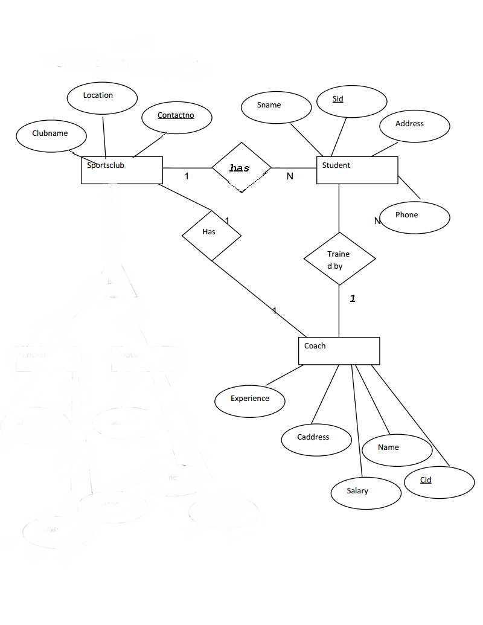

**DATA FLOW DIAGRAM**

The data flow diagram shows the flow of data within any system. It is an important tool for designing phase of software engineering. Larry Constantine first developed it. It represents graphical view of flow of data. It’s also known as BUBBLE CHART. The purpose of DFD is major transformation that will become in system design symbols used in DFD.

In the DFD, four symbols are used and they are as follows.

1. A square defines a source (originator) or destination of system data.
2. An arrow identifies data flow-data in motion. It is 2a pipeline through which information flows.
3. A circle or a “bubble “(Some people use an oval bubble) represents a process that transfers informing data flows into outgoing data flows.
4. An open rectangle is a data store-data at rest, or a temporary

Repository of data.

**Context Level Data Flow Diagram:-**

This level shows the overall context of the system and its operating environment and shows the whole system as just one process. Online book store is shown as one process in the context diagram; which is also known as zero level DFD, shown below. The context diagram plays important role in understanding the system and determining the boundaries. The main process can be broken into sub-processes and system can be studied with more detail; this is where 1st level DFD comes into play.

ADMIN

PLAYER

Request

COACH

Zero Level Data Flow Diagram

**First Level DFD:-**

This level (level 1) shows all processes at the first level of numbering, data stores, external entities and the data flows between them. The purpose of this level is to show the major high-level processes of the system and their interrelation. A process model will have one, and only one, level-1 diagram. A level-1 diagram must be balanced with its parent context level diagram, i.e. there must be the same external entities and the same data flows, these can be broken down to more detail in the level 1.

TRAINER

ADMIN

SCHEDULE

PLAYERS

One level data flow diagram

**Project Planning & Project Scheduling**

**PERT CHART**

A project plan needs to be created to ensure the timely completion of the project. As part of project analysis, we break the project down to a number of stages and use a Gantt chart and PERT chart to describe specific tasks and status.

The Work Breakdown Structure of our proposed system “E-Commerce” is shown below:

|  |  |  |  |  |  |  |  |  |  |
| --- | --- | --- | --- | --- | --- | --- | --- | --- | --- |
| ID |  | Task Name | Duration | Start | Finish | Predecessors | | | Resource Names |
| 1 |  | **Project Initiation** | 2 days |  |  |  | | |  |
| 2 |  | Draft Project Plan | 2 days |  |  |  | | |  |
| 3 |  | **Analysis Phase** | 7 days |  |  |  | | |  |
| 4 |  | Plan User Interviews | 2 days |  |  |  | | |  |
| 5 |  | Schedule users Interviews | 3 days |  |  |  | | |  |
| 6 |  | Conducting users Interviews | 2 days |  |  |  | | |  |
| 7 |  | **System Design** | 16 days |  |  | 6 | | |  |
| 8 |  | Modules Design | 10 days |  |  | |  |  | |
| 9 |  | Data Structure Design | 3 days |  |  | | 8 |  | |
| 10 |  | User Interface Design | 3 days |  |  | |  |  | |
| 11 |  | Coding Phase | 34 days |  |  | |  |  | |
| 12 |  | **Testing Phase** | 9 days |  |  | |  |  | |
| 13 |  | Integration Testing | 5 days |  |  | |  |  | |
| 14 |  | System Level Testing | 4 days |  |  | |  |  | |
| 15 |  | Implementation | 4 days |  |  | |  |  | |
| 16 |  | Post-Implementation Review | 2 days |  |  | |  |  | |

**DATABASE**

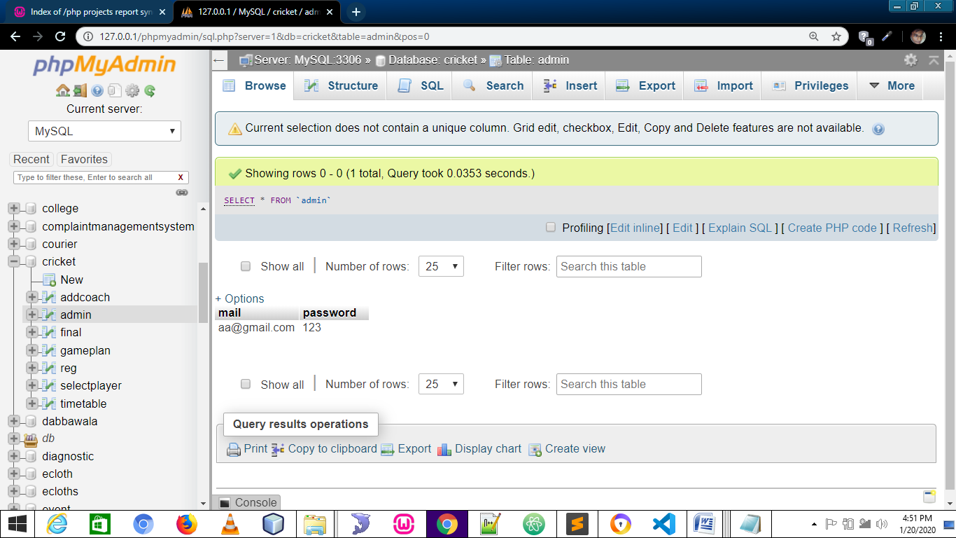 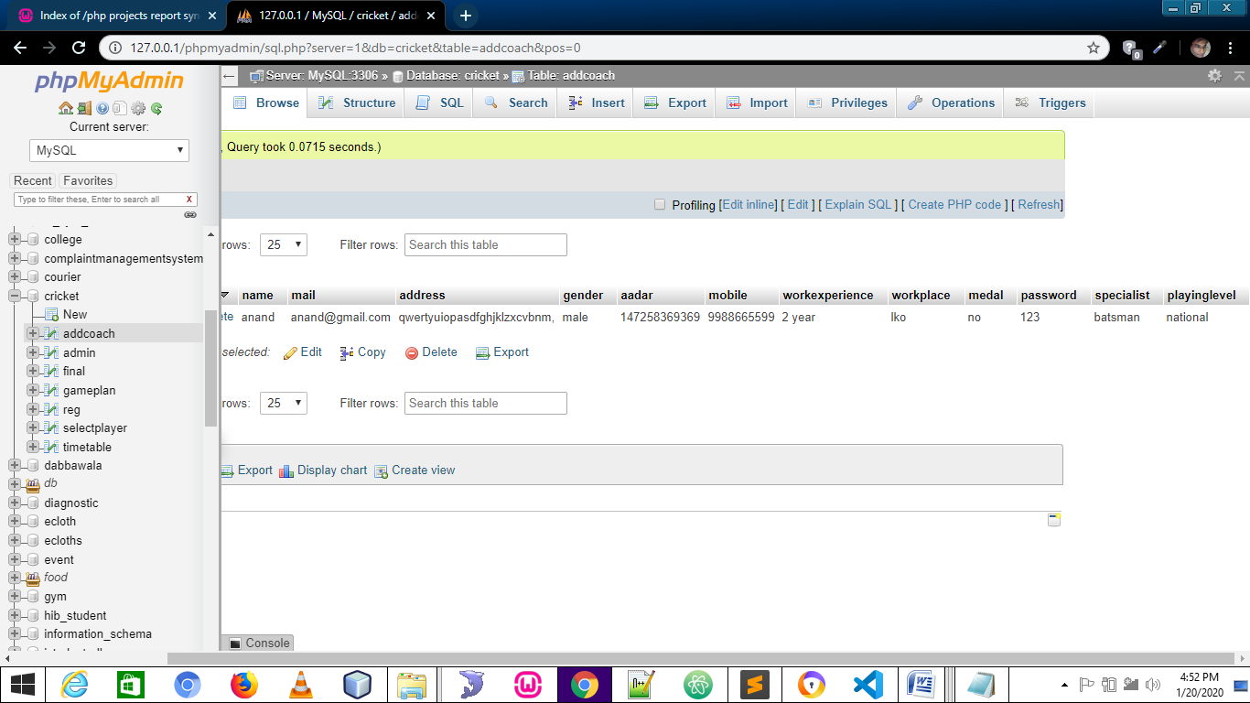 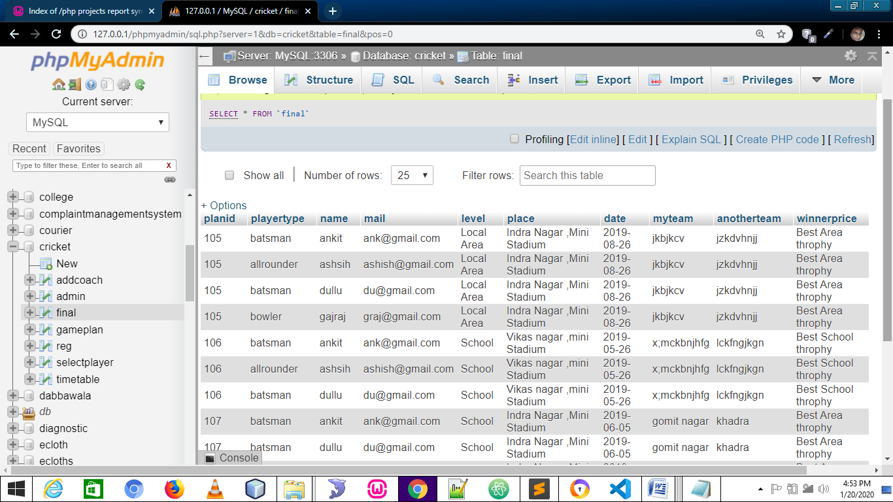 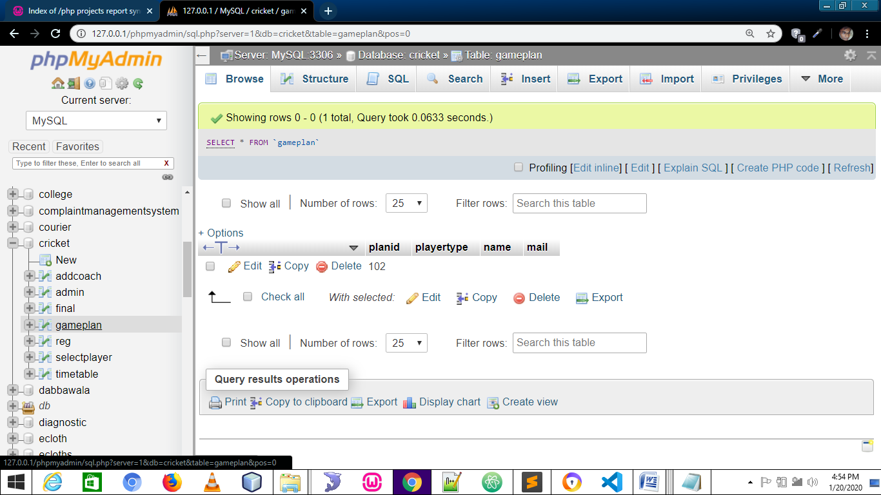 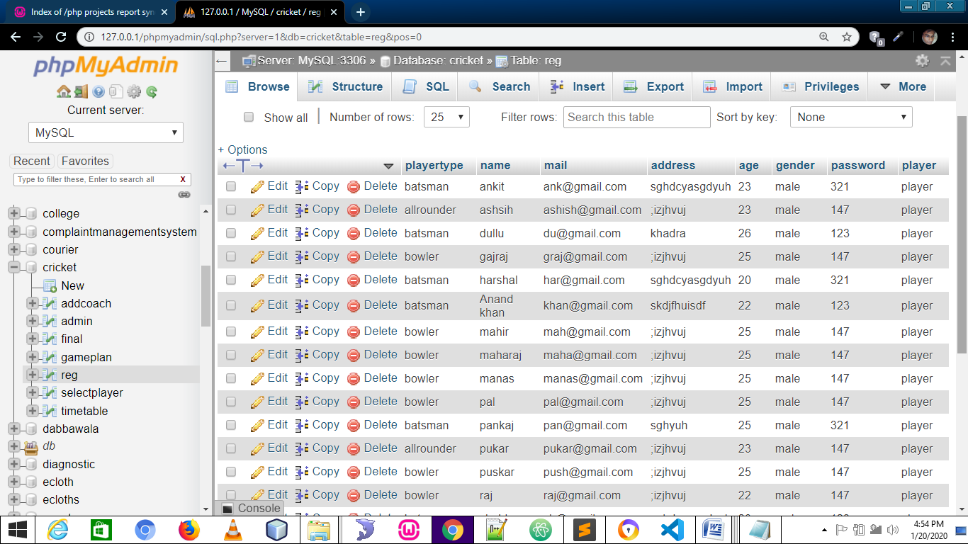 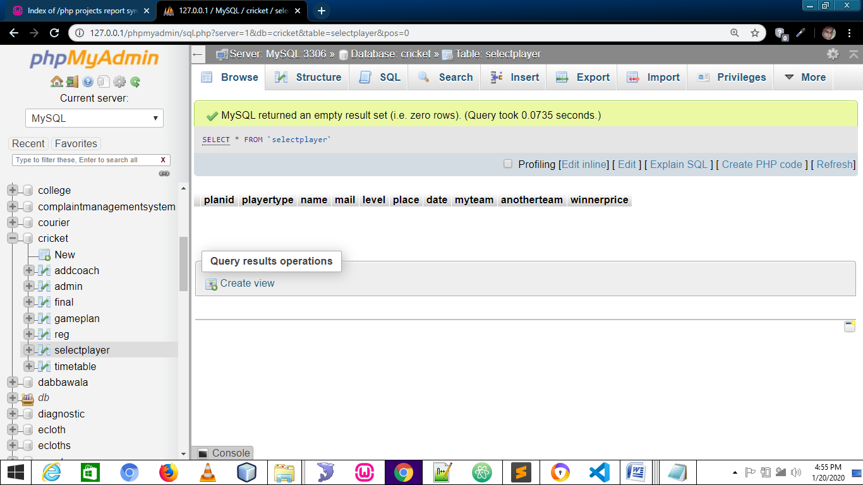 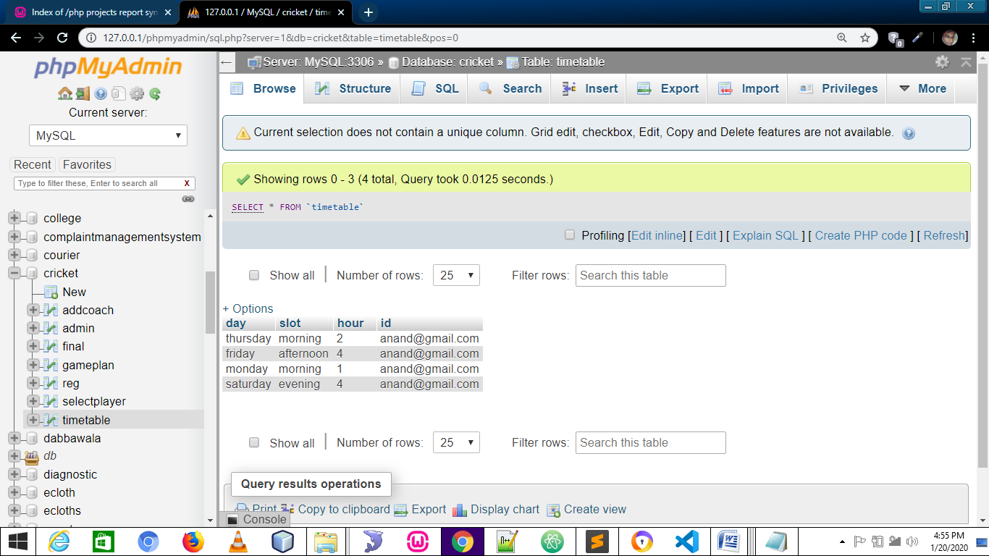

**SCREENSHOTS**

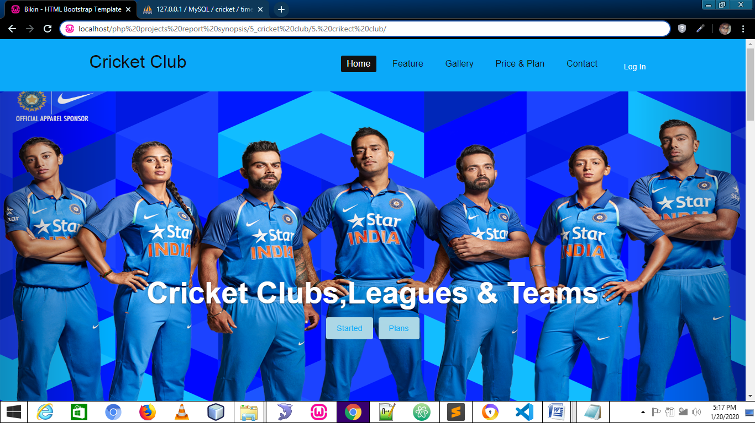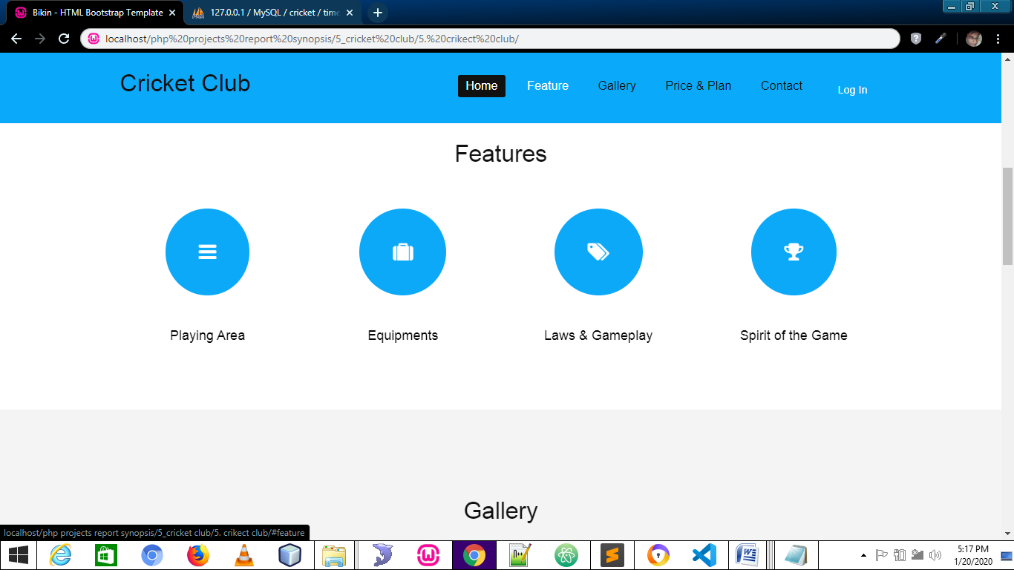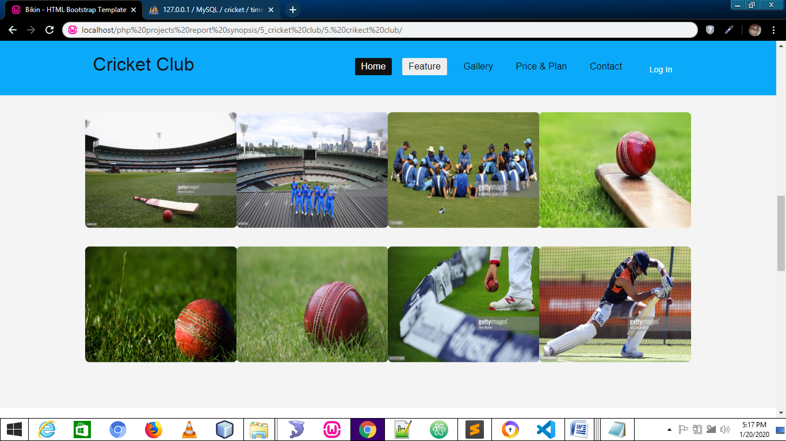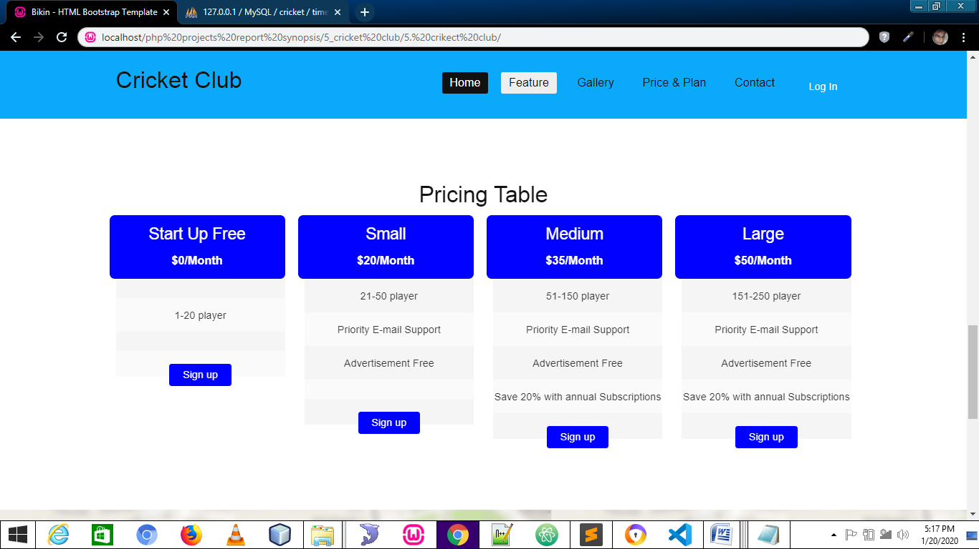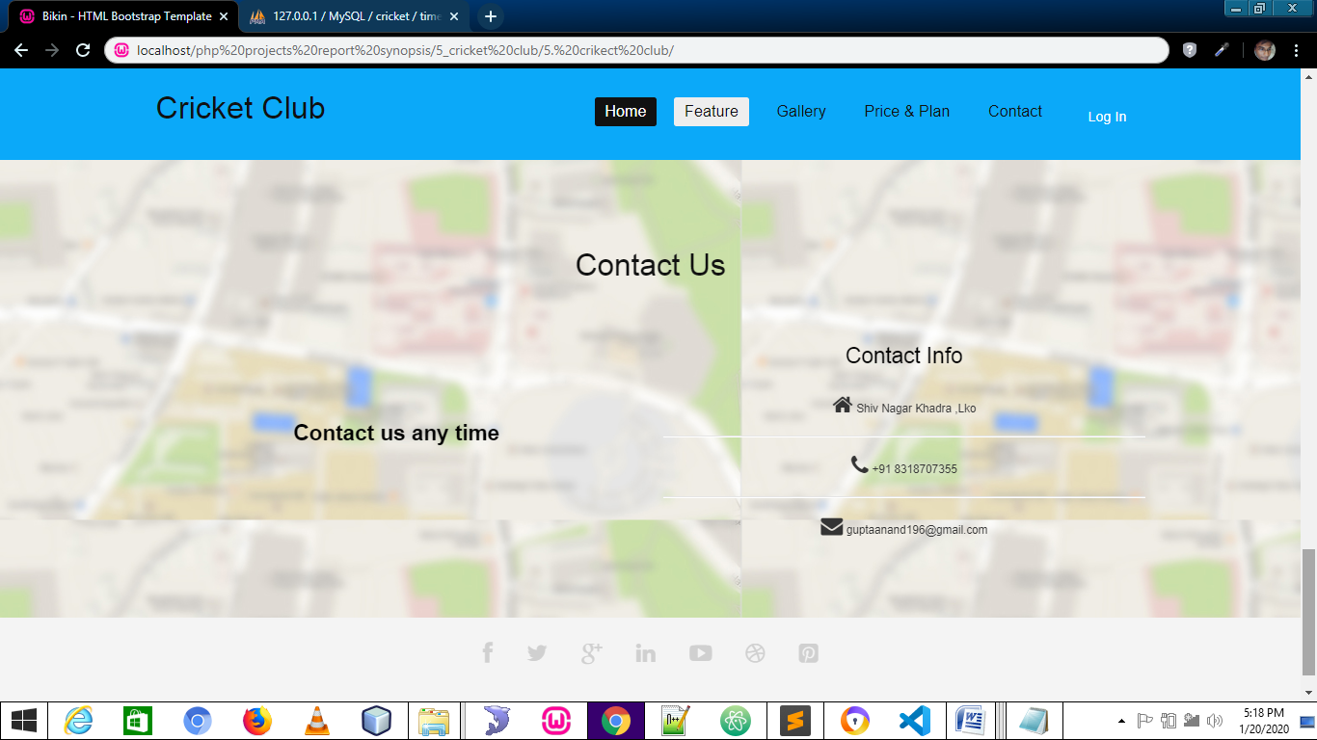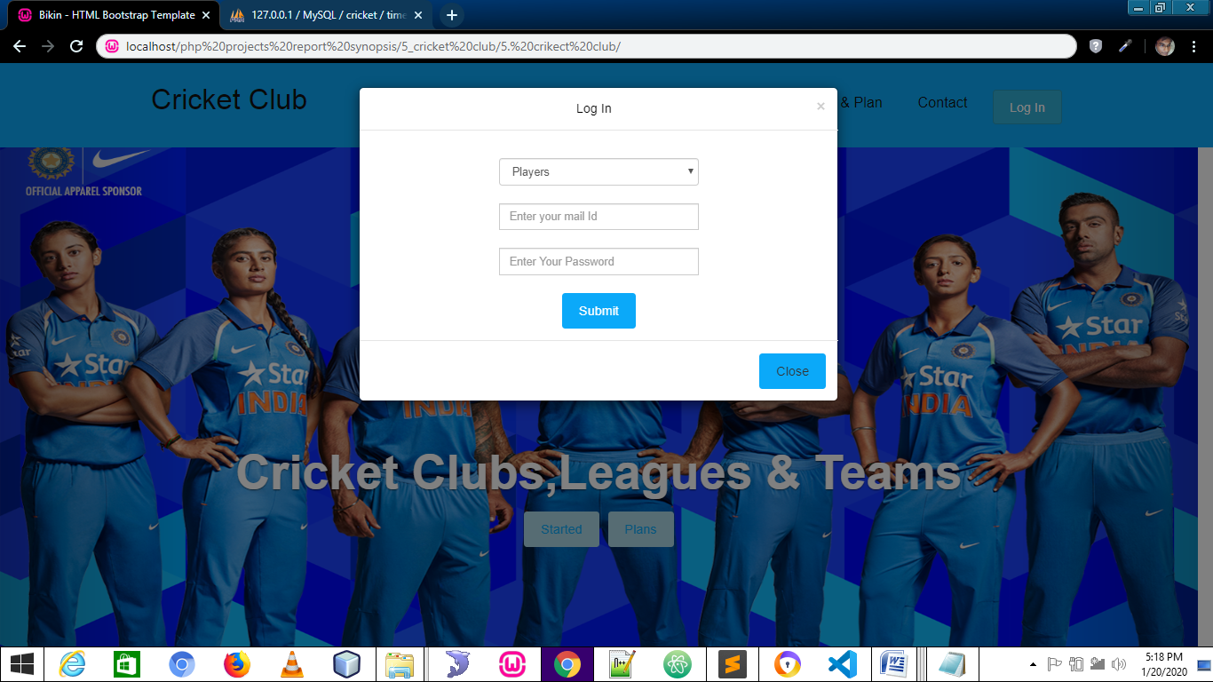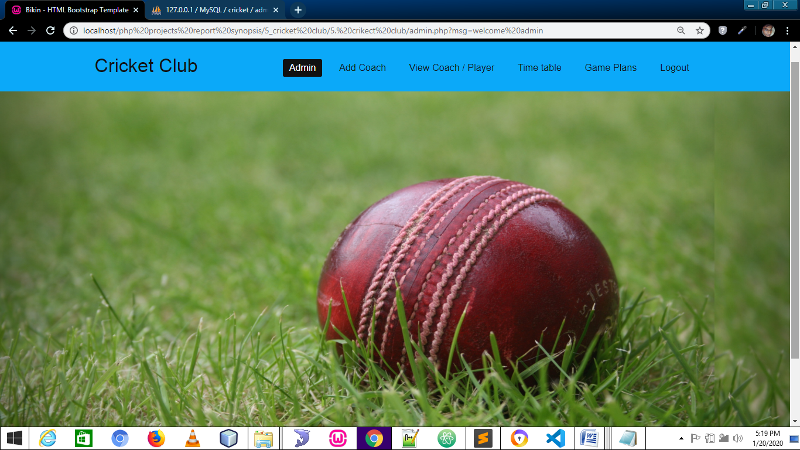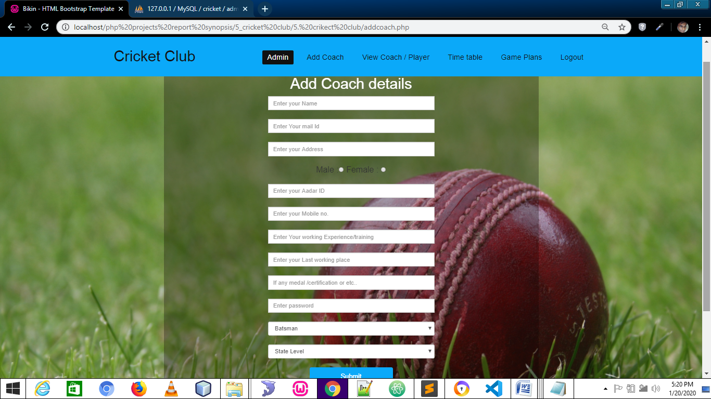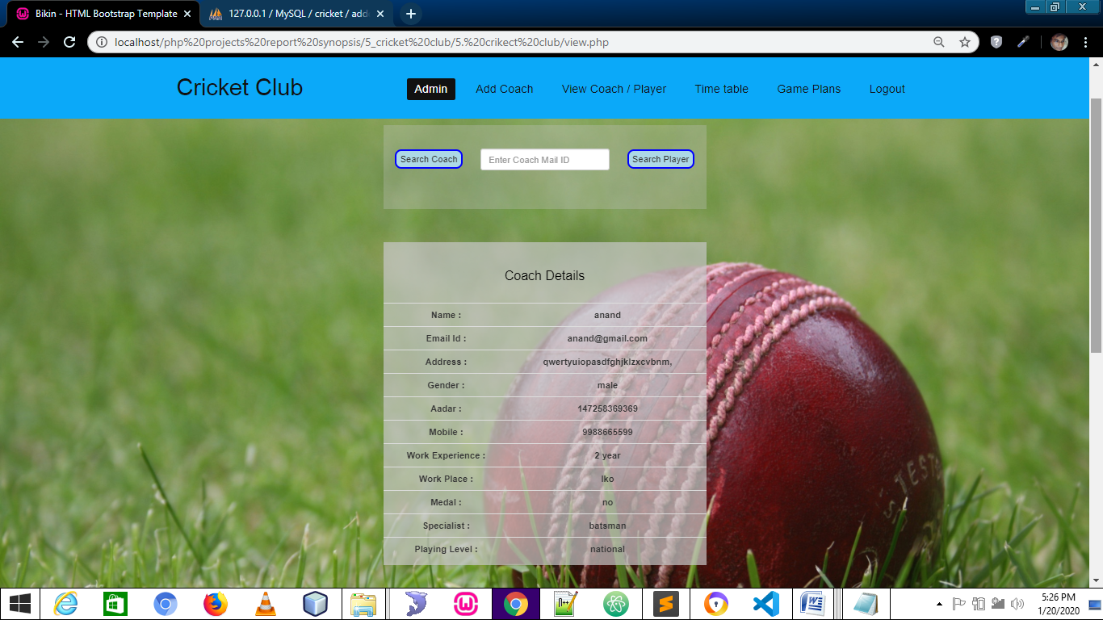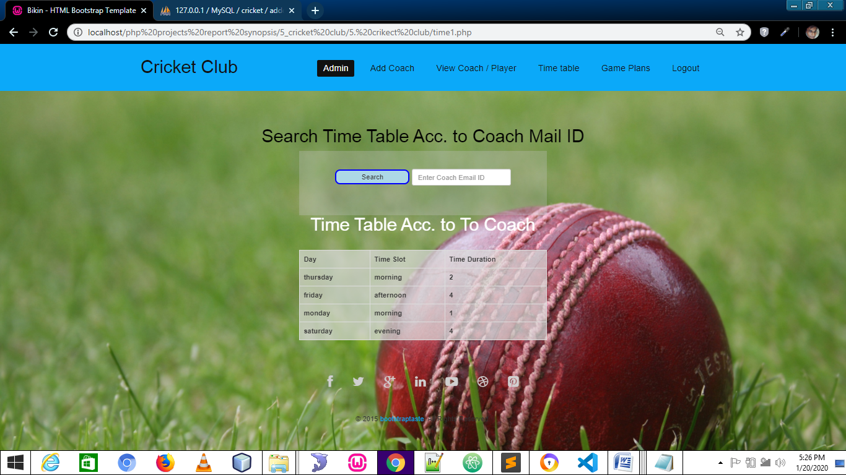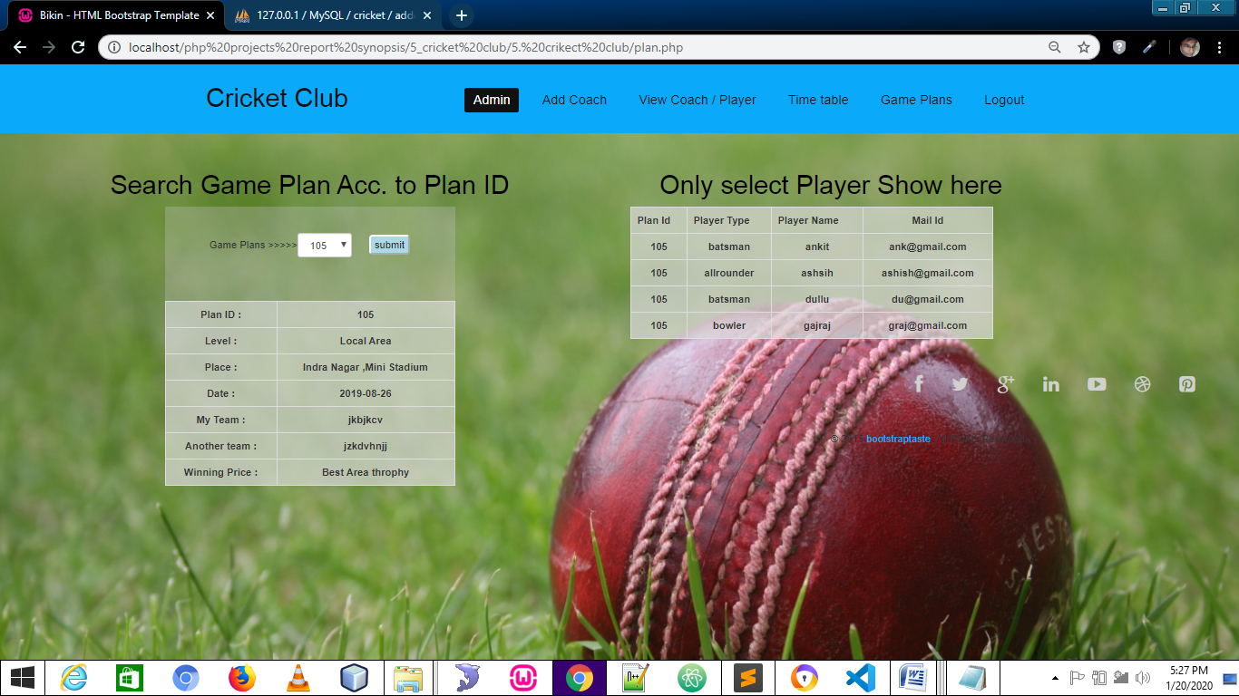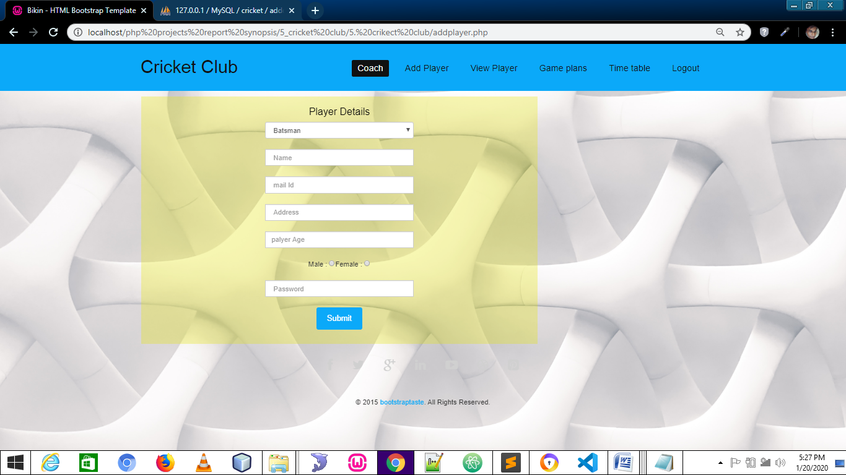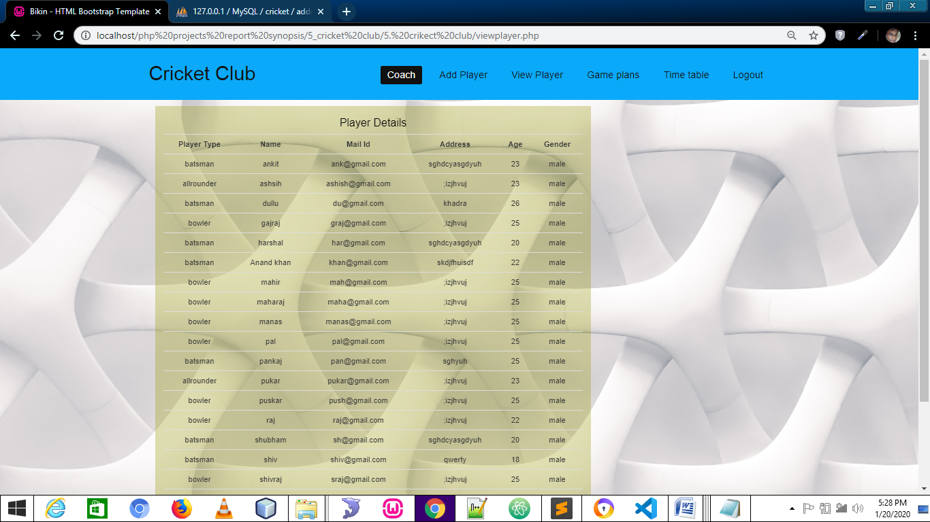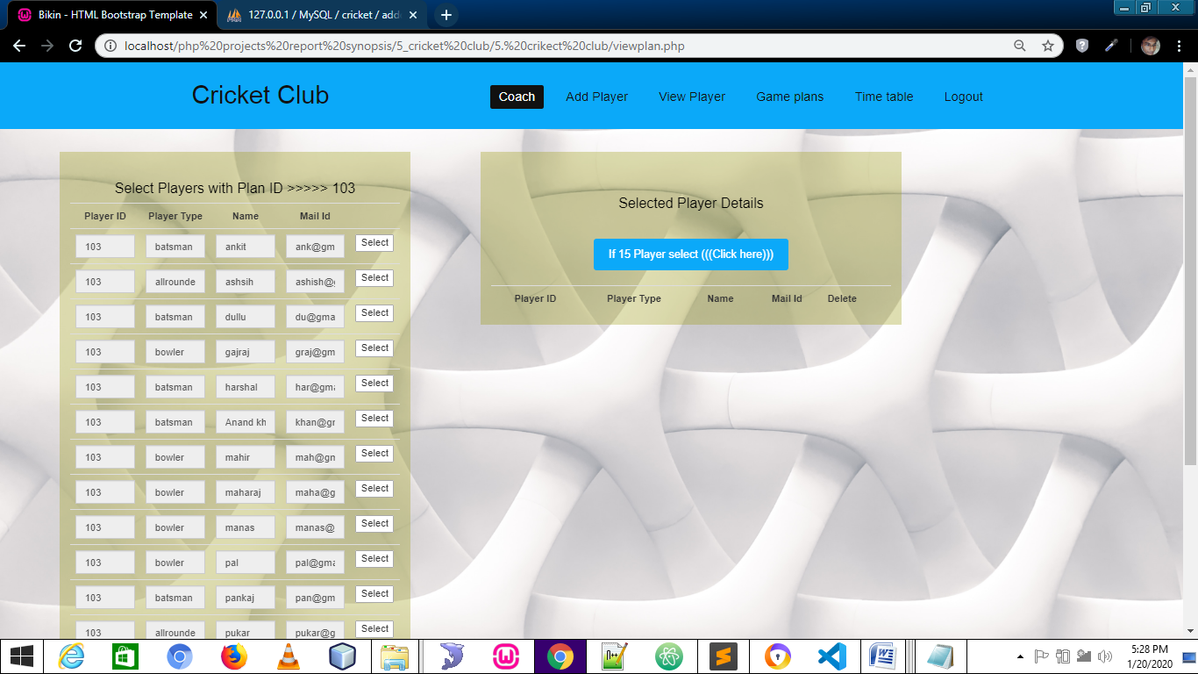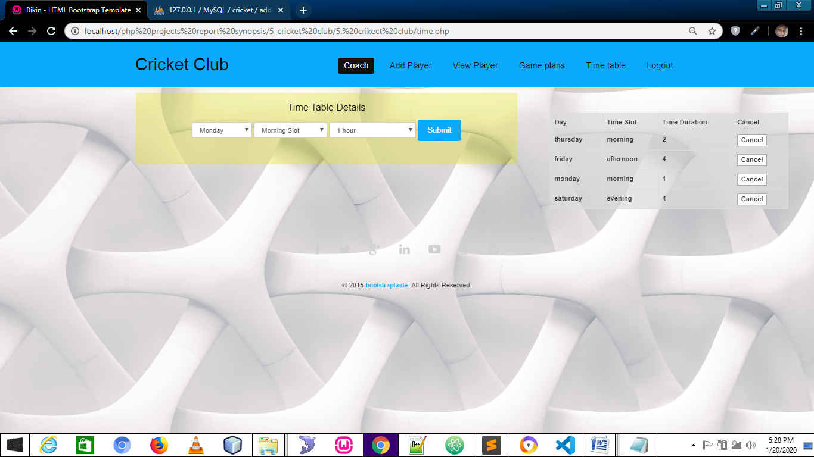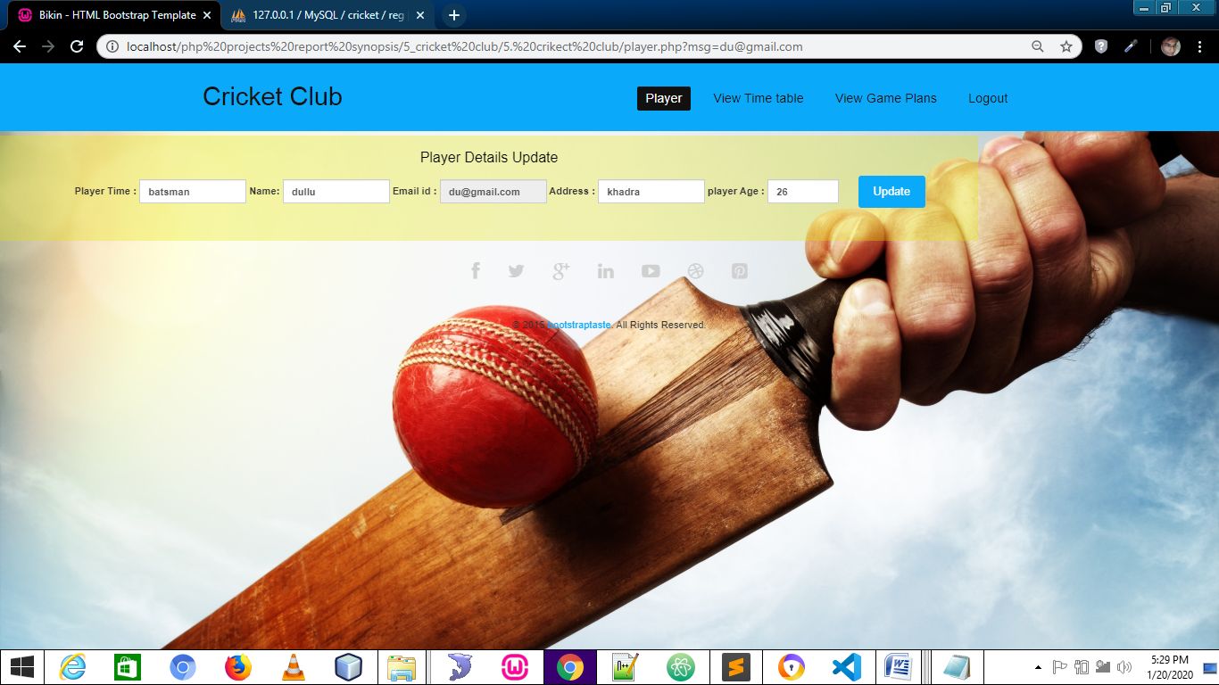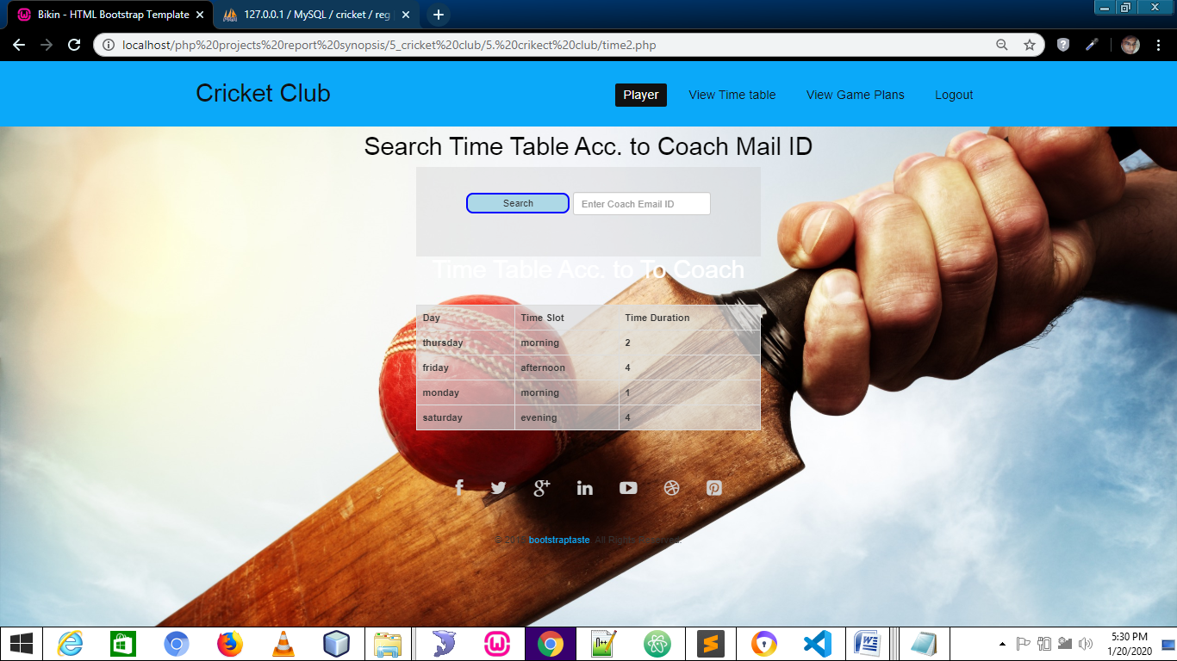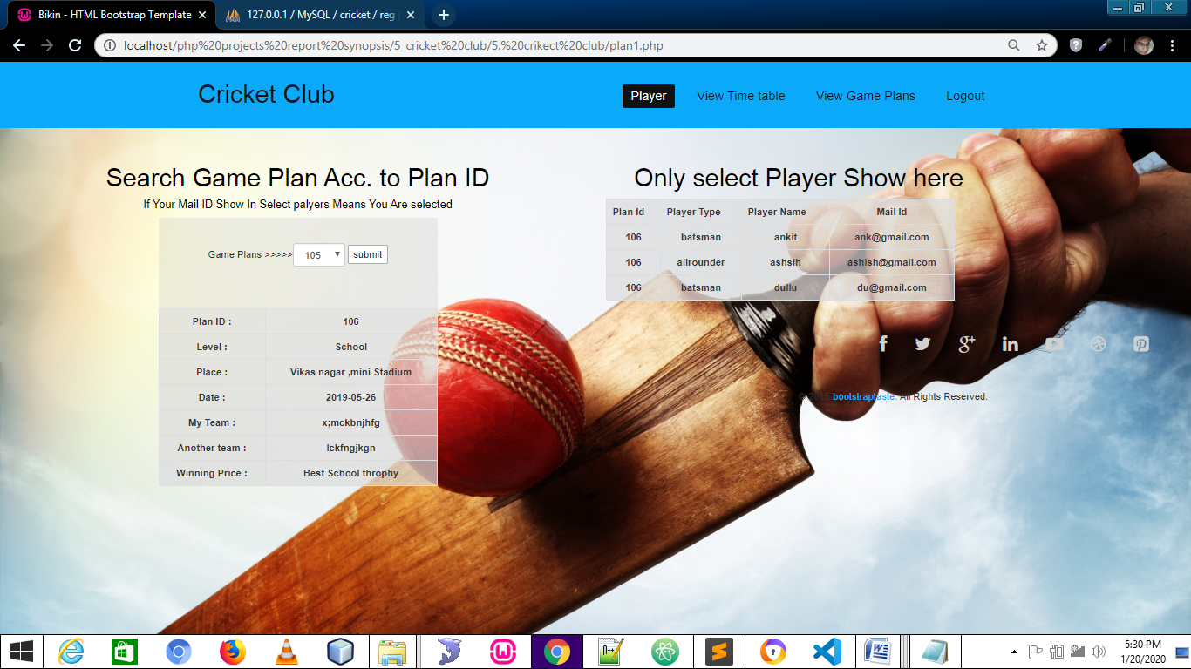

**CODING**

**Connect.php**

<?php

$con=mysqli_connect("localhost","root","","cricket");

if(!$con)

{

die("connection error".mysqli_connect_error());

}

?>

**Index.php**

<!DOCTYPE html>

<html lang="en">

<head>

<meta charset="utf-8">

<meta http-equiv="X-UA-Compatible" content="IE=edge">

<meta name="viewport" content="width=device-width, initial-scale=1">

<!-- The above 3 meta tags *must* come first in the head; any other head content must come *after* these tags -->

<title>Bikin - HTML Bootstrap Template</title>

<!-- Bootstrap -->

<link href="css/bootstrap.min.css" rel="stylesheet">

<link rel="stylesheet" href="css/font-awesome.min.css">

<link rel="stylesheet" href="css/animate.css">

<link rel="stylesheet" href="css/overwrite.css">

<link href="css/animate.min.css" rel="stylesheet">

<link href="css/style.css" rel="stylesheet" />

<!-- HTML5 shim and Respond.js for IE8 support of HTML5 elements and media queries -->

<!-- WARNING: Respond.js doesn't work if you view the page via file:// -->

<!--[if lt IE 9]>

<script src="https://oss.maxcdn.com/html5shiv/3.7.2/html5shiv.min.js"></script>

<script src="https://oss.maxcdn.com/respond/1.4.2/respond.min.js"></script>

<![endif]-->

</head>

<body>

<header id="header">

<nav class="navbar navbar-fixed-top" role="banner">

<div class="container">

<div class="navbar-header">

<button type="button" class="navbar-toggle" data-toggle="collapse" data-target=".navbar-collapse">

<span class="sr-only">Toggle navigation</span>

<span class="icon-bar"></span>

<span class="icon-bar"></span>

<span class="icon-bar"></span>

</button>

<a class="navbar-brand" href="index.html">Cricket Club</a>

</div>

<div class="collapse navbar-collapse navbar-right">

<ul class="nav navbar-nav">

<li class="active"><a href="#header">Home</a></li>

<li><a href="#feature">Feature</a></li>

<li><a href="#gallery">Gallery</a></li>

<li><a href="#pricing">Price & Plan</a></li>

<li><a href="#contact">Contact</a></li>

<li><button type="button" class="btn btn-info btn-lg" data-toggle="modal" data-target="#myModal">Log In</button>

</li>

</ul>

</div>

</div><!--/.container-->

</nav><!--/nav-->

</header><!--/header-->

<div class="modal fade" id="myModal" role="dialog">

<div class="modal-dialog">

<!-- Modal content-->

<div class="modal-content">

<div class="modal-header">

<button type="button" class="close" data-dismiss="modal">&times;</button>

<h4 class="modal-title" style="text-align:center">Log In</h4>

</div>

<div class="modal-body"><center>

<h2></h2>

<form action="login.php" method="post" style="width:250px;">

<select class="form-control" name="t1">

<option value="player">Players</option>

<option value="coach">Coaches</option>

<option value="admin"> Admin</option>

</select><br>

<input type="text" class="form-control" name="t2" placeholder="Enter your mail Id"><br>

<input type="text" class="form-control" name="t3" placeholder="Enter Your Password"><br>

<input type="submit" class="btn btn-warning" >

</form></center>

</div>

<div class="modal-footer">

<button type="button" class="btn btn-default" data-dismiss="modal">Close</button>

</div>

</div>

</div>

</div>

<div class="slider">

<div id="about-slider">

<!-- Indicators -->

<div class="carousel-inner">

<div class="item active">

<img src="img/abc1.png" style='height:700px;width:1355px' class="img-responsive" alt="" >

<div class="carousel-caption">

<div class="wow fadeInUp" data-wow-offset="0" data-wow-delay="0.3s">

<h2 ><span style="color:white"><b>Cricket Clubs,Leagues & Teams</b></span></h2>

</div>

<div class="wow fadeInUp" data-wow-offset="0" data-wow-delay="0.6s">

</div>

<div class="wow fadeInUp" data-wow-offset="0" data-wow-delay="0.9s">

<form class="form-inline">

<button class="btn btn-warning btn-lg " style="background-color:lightblue;"><a href="#feature" style="border-radius:10px;width:100px;height:50px;">Started</button></a>

<button class="btn btn-warning btn-lg" style="background-color:lightblue;"><a href="#pricing" style="border-radius:10px;width:100px;height:50px;"> Plans</a></button>

</div>

</form>

</div>

</div>

</div>

</div>

<a class="left carousel-control hidden-xs" href="#carousel-slider" data-slide="prev">

<i class="fa fa-angle-left"></i>

</a>

<a class=" right carousel-control hidden-xs"href="#carousel-slider" data-slide="next">

<i class="fa fa-angle-right"></i>

</a>

<!--/#carousel-slider-->

</div><!--/#about-slider-->

</div><!--/#slider-->

<div class="modal fade" id="myModal1" role="dialog">

<div class="modal-dialog">

<!-- Modal content-->

<div class="modal-content">

<div class="modal-header">

<button type="button" class="close" data-dismiss="modal">&times;</button>

<h4 class="modal-title">Sign Up</h4>

</div>

<div class="modal-body">

<form action="reg.php" method="post" style="width:300px;">

<input type="text" class="form-control" name="t1" placeholder="Enter your Name"><br>

<input type="email" class="form-control" name="t2" placeholder="Enter Your mail Id"><br>

<input type="text" class="form-control" name="t3" placeholder="Enter your Address"><br>

<input type="number" class="form-control" name="t4" placeholder="Enter Your Age"><br>

Male : <input type="radio" name="t5" value="male" placeholder="Enter your mail Id">Female : <input type="radio" name="t5" value="female" placeholder="Enter your mail Id"><br><br>

<input type="password" class="form-control" name="t6" placeholder="Enter Your Password"><br>

<input type="submit" class="btn btn-warning" >

</form>

</div>

<div class="modal-footer">

<button type="button" class="btn btn-default" data-dismiss="modal">Close</button>

</div>

</div>

</div>

</div>

<div id="feature">

<div class="container">

<div class="row">

<div class="text-center">

<h3>Features</h3>

</div>

<div class="col-md-3 wow fadeInRight" data-wow-offset="0" data-wow-delay="0.3s">

<div class="text-center">

<div class="hi-icon-wrap hi-icon-effect">

<i class="fa fa-bars"></i>

<h2>Playing Area</h2>

</div>

</div>

</div>

<div class="col-md-3 wow fadeInRight" data-wow-offset="0" data-wow-delay="0.3s">

<div class="text-center">

<div class="hi-icon-wrap hi-icon-effect">

<i class="fa fa-suitcase"></i>

<h2>Equipments</h2>

</div>

</div>

</div>

<div class="col-md-3 wow fadeInLeft" data-wow-offset="0" data-wow-delay="0.3s">

<div class="text-center">

<div class="hi-icon-wrap hi-icon-effect">

<i class="fa fa-tags"></i>

<h2>Laws & Gameplay</h2>

</div>

</div>

</div>

<div class="col-md-3 wow fadeInLeft" data-wow-offset="0" data-wow-delay="0.3s">

<div class="text-center">

<div class="hi-icon-wrap hi-icon-effect">

<i class="fa fa-trophy"></i>

<h2>Spirit of the Game</h2>

</div>

</div>

</div>

</div>

</div>

</div>

<div id="gallery">

<div class="container">

<div class="text-center">

<h3>Gallery</h3>

</div>

<div class="row">

<figure class="effect-chico">

<div class="col-md-3 wow fadeInUp" data-wow-offset="0" data-wow-delay="0.3s" >

<a href="img/1.jpg" class="flipLightBox">

<img src="img/1.jpg" class="img-responsive" alt="" style="height:200px;">

</a>

</div>

</figure>

<figure class="effect-chico">

<div class="col-md-3 wow fadeInUp" data-wow-offset="0" data-wow-delay="0.3s">

<a href="img/2.jpg" class="flipLightBox">

<img src="img/2.jpg" class="img-responsive" alt="" style="height:200px;">

</a>

</div>

</figure>

<figure class="effect-chico">

<div class="col-md-3 wow fadeInDown" data-wow-offset="0" data-wow-delay="0.3s">

<a href="img/3.jpg" class="flipLightBox">

<img src="img/3.jpg" class="img-responsive" alt="" style="height:200px;">

</a>

</div>

</figure>

<figure class="effect-chico">

<div class="col-md-3 wow fadeInDown" data-wow-offset="0" data-wow-delay="0.3s">

<a href="img/4.jpg" class="flipLightBox">

<img src="img/4.jpg" class="img-responsive" alt="" style="height:200px;">

</a>

</div>

</figure>

</div>

</div>

<div class="gallery">

<div class="container">

<div class="row">

<figure class="effect-chico">

<div class="col-md-3 wow fadeInUp" data-wow-offset="0" data-wow-delay="0.3s">

<a href="img/5.jpg" class="flipLightBox">

<img src="img/5.jpg" class="img-responsive" alt="" style="height:200px;">

</a>

</div>

</figure>

<figure class="effect-chico">

<div class="col-md-3 wow fadeInUp" data-wow-offset="0" data-wow-delay="0.3s">

<a href="img/6.jpg" class="flipLightBox">

<img src="img/6.jpg" class="img-responsive" alt="" style="height:200px;">

</a>

</div>

</figure>

<figure class="effect-chico">

<div class="col-md-3 wow fadeInDown" data-wow-offset="0" data-wow-delay="0.3s">

<a href="img/7.jpg" class="flipLightBox">

<img src="img/7.jpg" class="img-responsive" alt="" style="height:200px;">

</a>

</div>

</figure>

<figure class="effect-chico">

<div class="col-md-3 wow fadeInDown" data-wow-offset="0" data-wow-delay="0.3s">

<a href="img/8.jpg" class="flipLightBox">

<img src="img/8.jpg" class="img-responsive" alt="" style="height:200px;">

</a>

</div>

</figure>

</div>

</div>

</div>

</div><!--/#gallery-->

<div id="pricing">

<div class="container">

<div class="text-center">

<h3>Pricing Table</h3>

</div>

<div class="pricing-area text-center">

<div class="row">

<div class="col-sm-3 plan price-one wow fadeInDown" data-wow-offset="0" data-wow-delay="0.2s" style="height:550px;">

<ul>

<li class="heading-three" style="background-color:blue">

<h2>Start Up Free</h2>

<span>$0/Month</span>

</li><li></li>

<li>1-20 player</li>

<li></li>

<li class="plan-action">

<a href="" class="btn btn-primary" style="background-color:blue">Sign up</a>

</li>

</ul>

</div>

<div class="col-sm-3 plan price-two wow fadeInDown" data-wow-offset="0" data-wow-delay="0.6s" style="height:550px;">

<ul>

<li class="heading-three" style="background-color:blue">

<h2>Small</h2>

<span>$20/Month</span>

</li>

<li>21-50 player</li>

<li>Priority E-mail Support </li>

<li>Advertisement Free</li>

<li></li>

<li class="plan-action">

<a href="" class="btn btn-primary" style="background-color:blue">Sign up</a>

</li>

</ul>

</div>

<div class="col-sm-3 plan price-three wow fadeInDown" data-wow-offset="0" data-wow-delay="0.9s" style="height:550px;">

<ul>

<li class="heading-three" style="background-color:blue">

<h2>Medium</h2>

<span>$35/Month</span>

</li>

<li>51-150 player</li>

<li>Priority E-mail Support </li>

<li>Advertisement Free</li>

<li>Save 20% with annual Subscriptions</li>

<li class="plan-action">

<a href="" class="btn btn-primary" style="background-color:blue">Sign up</a>

</li>

</ul>

</div>

<div class="col-sm-3 plan price-three wow fadeInDown" data-wow-offset="0" data-wow-delay="0.9s" style="height:550px;">

<ul>

<li class="heading-three" style="background-color:blue">

<h2>Large</h2>

<span>$50/Month</span>

</li>

<li>151-250 player</li>

<li>Priority E-mail Support </li>

<li>Advertisement Free</li>

<li>Save 20% with annual Subscriptions</li>

<li class="plan-action">

<a href="" class="btn btn-primary" style="background-color:blue">Sign up</a>

</li>

</ul>

</div>

</div>

</div><!--/pricing-area-->

</div>

</div><!--/#pricing-->

<footer>

<div id="contact">

<div class="container">

<div class="text-center">

<h3>Contact Us</h3>

</div>

</div>

<div class="container">

<div class="row">

<div class="col-md-6 wow fadeInUp" data-wow-offset="0" data-wow-delay="0.2s"><br><br><br><br>

<h2 style="text-align:center"><b>Contact us any time</b></h2>

</div>

<div class="col-md-6 wow fadeInUp" data-wow-offset="0" data-wow-delay="0.4s">

<h2 style="text-align:center">Contact Info</h2>

<ul>

<li style="text-align:center"><i class="fa fa-home fa-2x"></i> Shiv Nagar Khadra ,Lko</li><hr>

<li style="text-align:center"><i class="fa fa-phone fa-2x"></i> +91 8318707355</li><hr>

<li style="text-align:center"><i class="fa fa-envelope fa-2x"></i> guptaanand196@gmail.com</li>

</ul>

</div>

</div>

</div>

</div><!--/#contact-->

<div class="social-icon">

<div class="container">

<div class="col-md-6 col-md-offset-3">

<ul class="social-network">

<li><a href="#" class="fb tool-tip" title="Facebook"><i class="fa fa-facebook"></i></a></li>

<li><a href="#" class="twitter tool-tip" title="Twitter"><i class="fa fa-twitter"></i></a></li>

<li><a href="#" class="gplus tool-tip" title="Google Plus"><i class="fa fa-google-plus"></i></a></li>

<li><a href="#" class="linkedin tool-tip" title="Linkedin"><i class="fa fa-linkedin"></i></a></li>

<li><a href="#" class="ytube tool-tip" title="You Tube"><i class="fa fa-youtube-play"></i></a></li>

<li><a href="#" class="dribbble tool-tip" title="Dribbble"><i class="fa fa-dribbble"></i></a></li>

<li><a href="#" class="pinterest tool-tip" title="Pinterest"><i class="fa fa-pinterest-square"></i></a></li>

</ul>

</div>

</div>

</div>

<div class="text-center">

<div class="copyright">

&copy; 2015 <a target="_blank" href="http://bootstraptaste.com/" title="Free Twitter Bootstrap WordPress Themes and HTML templates">bootstraptaste</a>. All Rights Reserved.

</div>

<!--

All links in the footer should remain intact.

Licenseing information is available at: http://bootstraptaste.com/license/

You can buy this theme without footer links online at: http://bootstraptaste.com/buy/?theme=Bikin

-->

</div>

</footer>

<!-- jQuery (necessary for Bootstrap's JavaScript plugins) -->

<script src="js/jquery-2.1.1.min.js"></script>

<!-- Include all compiled plugins (below), or include individual files as needed -->

<script src="js/bootstrap.min.js"></script>

<script src="js/parallax.min.js"></script>

<script src="js/wow.min.js"></script>

<script src="js/jquery.easing.min.js"></script>

<script type="text/javascript" src="js/fliplightbox.min.js"></script>

<script src="js/functions.js"></script>

<script>

wow = new WOW(

{

} )

.init();

</script>

</body>

</html>

**Login.php**

<?php

include 'connect.php';

session_start();

if($_SERVER['REQUEST_METHOD']=="POST")

{

$a=$_POST['t1'];

$b=$_POST['t2'];

$c=$_POST['t3'];

if($a=='player')

{

$sql="select password from reg where mail='$b'";

$result=mysqli_query($con,$sql);

if($row=mysqli_fetch_assoc($result))

{ $dbpswd=$row['password'];

if($c==$dbpswd)

{

$_SESSION['em']=$b;

header("location:player.php?msg=$b");

}}

else{

header("location:home.php?msg=error1");

}

}else if($a=='coach')

{

$sql="select password from addcoach where mail='$b'";

$result=mysqli_query($con,$sql);

if($row=mysqli_fetch_assoc($result))

{ $dbpswd=$row['password'];

if($c==$dbpswd)

{

$_SESSION['em']=$b;

header("location:coach.php?msg=welcome admin");

} else{

header("location:home.php?msg=error3");

}

}else{

header("location:home.php?msg=errorrrr");

} }else if($a==admin)

{

$sql="select password from admin where mail='$b'";

$result=mysqli_query($con,$sql);

if($row=mysqli_fetch_assoc($result))

{ $dbpswd=$row['password'];

if($c==$dbpswd)

{

$_SESSION['em']=$a;

header("location:admin.php?msg=welcome admin");

}}

else{

header("location:home.php?msg=error3");

}

}

}

?>

**Admin.php**

<!DOCTYPE html>

<html lang="en">

<head>

<meta charset="utf-8">

<meta http-equiv="X-UA-Compatible" content="IE=edge">

<meta name="viewport" content="width=device-width, initial-scale=1">

<!-- The above 3 meta tags *must* come first in the head; any other head content must come *after* these tags -->

<title>Bikin - HTML Bootstrap Template</title>

<!-- Bootstrap -->

<link href="css/bootstrap.min.css" rel="stylesheet">

<link rel="stylesheet" href="css/font-awesome.min.css">

<link rel="stylesheet" href="css/animate.css">

<link rel="stylesheet" href="css/overwrite.css">

<link href="css/animate.min.css" rel="stylesheet">

<link href="css/style.css" rel="stylesheet" />

<!-- HTML5 shim and Respond.js for IE8 support of HTML5 elements and media queries -->

<!-- WARNING: Respond.js doesn't work if you view the page via file:// -->

<!--[if lt IE 9]>

<script src="https://oss.maxcdn.com/html5shiv/3.7.2/html5shiv.min.js"></script>

<script src="https://oss.maxcdn.com/respond/1.4.2/respond.min.js"></script>

<![endif]-->

</head>

<body style=" height:100%;background-image:url(img/cricket_ball_in_the_grass-2560x1600.jpg); background-size:cover;background-attachment:fixed; ">

<header id="header">

<nav class="navbar navbar-fixed-top" role="banner">

<div class="container">

<div class="navbar-header">

<button type="button" class="navbar-toggle" data-toggle="collapse" data-target=".navbar-collapse">

<span class="sr-only">Toggle navigation</span>

<span class="icon-bar"></span>

<span class="icon-bar"></span>

<span class="icon-bar"></span>

</button>

<a class="navbar-brand" >Cricket Club</a>

</div>

<div class="collapse navbar-collapse navbar-right">

<ul class="nav navbar-nav">

<li class="active"><a href="admin.php">Admin</a></li>

<li><a href="addcoach.php">Add Coach</a></li>

<li><a href="view.php">View Coach / Player </a></li>

<li><a href="time1.php">Time table</a></li>

<li><a href="plan.php">Game Plans</a></li>

<li><a href="logout.php">Logout</a></li>

</ul>

</div>

</div><!--/.container-->

</nav><!--/nav-->

</header><!--/header-->

<div class="modal fade" id="myModal" role="dialog">

<div class="modal-dialog">

</div>

</div>

<div class="slider">

<div id="about-slider">

<!-- Indicators -->

<div class="carousel-inner">

<div class="item active">

<img src="img/cricket_ball_in_the_grass-2560x1600.jpg" style='height:700px;width:1355px' class="img-responsive" alt="" >

</div>

</div>

</div>

<a class="left carousel-control hidden-xs" href="#carousel-slider" data-slide="prev">

<i class="fa fa-angle-left"></i>

</a>

<a class=" right carousel-control hidden-xs"href="#carousel-slider" data-slide="next">

<i class="fa fa-angle-right"></i>

</a>

<!--/#carousel-slider-->

</div><!--/#about-slider-->

</div><!--/#slider-->

<div class="modal fade" id="myModal1" role="dialog">

<div class="modal-dialog">

<div class="modal-footer">

<button type="button" class="btn btn-default" data-dismiss="modal">Close</button>

</div>

</div>

</div>

</div>

<div class="social-icon">

<div class="container">

<div class="col-md-6 col-md-offset-3">

<ul class="social-network">

<li><a href="#" class="fb tool-tip" title="Facebook"><i class="fa fa-facebook"></i></a></li>

<li><a href="#" class="twitter tool-tip" title="Twitter"><i class="fa fa-twitter"></i></a></li>

<li><a href="#" class="gplus tool-tip" title="Google Plus"><i class="fa fa-google-plus"></i></a></li>

<li><a href="#" class="linkedin tool-tip" title="Linkedin"><i class="fa fa-linkedin"></i></a></li>

<li><a href="#" class="ytube tool-tip" title="You Tube"><i class="fa fa-youtube-play"></i></a></li>

<li><a href="#" class="dribbble tool-tip" title="Dribbble"><i class="fa fa-dribbble"></i></a></li>

<li><a href="#" class="pinterest tool-tip" title="Pinterest"><i class="fa fa-pinterest-square"></i></a></li>

</ul>

</div>

</div>

</div>

<div class="text-center">

<div class="copyright">

&copy; 2015 <a target="_blank" href="http://bootstraptaste.com/" title="Free Twitter Bootstrap WordPress Themes and HTML templates">bootstraptaste</a>. All Rights Reserved.

</div>

<!--

All links in the footer should remain intact.

Licenseing information is available at: http://bootstraptaste.com/license/

You can buy this theme without footer links online at: http://bootstraptaste.com/buy/?theme=Bikin

-->

</div>

</footer>

<!-- jQuery (necessary for Bootstrap's JavaScript plugins) -->

<script src="js/jquery-2.1.1.min.js"></script>

<!-- Include all compiled plugins (below), or include individual files as needed -->

<script src="js/bootstrap.min.js"></script>

<script src="js/parallax.min.js"></script>

<script src="js/wow.min.js"></script>

<script src="js/jquery.easing.min.js"></script>

<script type="text/javascript" src="js/fliplightbox.min.js"></script>

<script src="js/functions.js"></script>

<script>

wow = new WOW(

{

} )

.init();

</script>

</body>

</html>

**Coach.php**

<?php

session_start();

$se=$_SESSION['em'];

if($se==null){

header("location:home.php?msg=plz login first");

}

?>

<!DOCTYPE html>

<html lang="en">

<head>

<meta charset="utf-8">

<meta http-equiv="X-UA-Compatible" content="IE=edge">

<meta name="viewport" content="width=device-width, initial-scale=1">

<!-- The above 3 meta tags *must* come first in the head; any other head content must come *after* these tags -->

<title>Bikin - HTML Bootstrap Template</title>

<!-- Bootstrap -->

<link href="css/bootstrap.min.css" rel="stylesheet">

<link rel="stylesheet" href="css/font-awesome.min.css">

<link rel="stylesheet" href="css/animate.css">

<link rel="stylesheet" href="css/overwrite.css">

<link href="css/animate.min.css" rel="stylesheet">

<link href="css/style.css" rel="stylesheet" />

<!-- HTML5 shim and Respond.js for IE8 support of HTML5 elements and media queries -->

<!-- WARNING: Respond.js doesn't work if you view the page via file:// -->

<!--[if lt IE 9]>

<script src="https://oss.maxcdn.com/html5shiv/3.7.2/html5shiv.min.js"></script>

<script src="https://oss.maxcdn.com/respond/1.4.2/respond.min.js"></script>

<![endif]-->

</head>

<body style="background-image:url(jj-ying-236821-unsplash.jpg) ;background-size:cover;">

<header id="header">

<nav class="navbar navbar-fixed-top" role="banner">

<div class="container">

<div class="navbar-header">

<button type="button" class="navbar-toggle" data-toggle="collapse" data-target=".navbar-collapse">

<span class="sr-only">Toggle navigation</span>

<span class="icon-bar"></span>

<span class="icon-bar"></span>

<span class="icon-bar"></span>

</button>

<a class="navbar-brand" href="index.html">Cricket Club</a>

</div>

<div class="collapse navbar-collapse navbar-right">

<ul class="nav navbar-nav">

<li class="active"><a href="#header">Coach</a></li>

<li><a href="addplayer.php">Add Player</a></li>

<li><a href="viewplayer.php">View Player</a></li>

<li><a href="viewplan.php">Game plans</a></li>

<li><a href="time.php">Time table</a></li>

<li><a href="logout.php">Logout</a></li>

</ul>

</div>

</div><!--/.container-->

</nav><!--/nav-->

</header><!--/header-->

<!--/#contact-->

<div class="social-icon">

<div class="container">

<div class="col-md-6 col-md-offset-3">

<ul class="social-network">

<li><a href="#" class="fb tool-tip" title="Facebook"><i class="fa fa-facebook"></i></a></li>

<li><a href="#" class="twitter tool-tip" title="Twitter"><i class="fa fa-twitter"></i></a></li>

<li><a href="#" class="gplus tool-tip" title="Google Plus"><i class="fa fa-google-plus"></i></a></li>

<li><a href="#" class="linkedin tool-tip" title="Linkedin"><i class="fa fa-linkedin"></i></a></li>

<li><a href="#" class="ytube tool-tip" title="You Tube"><i class="fa fa-youtube-play"></i></a></li>

<li><a href="#" class="dribbble tool-tip" title="Dribbble"><i class="fa fa-dribbble"></i></a></li>

<li><a href="#" class="pinterest tool-tip" title="Pinterest"><i class="fa fa-pinterest-square"></i></a></li>

</ul>

</div>

</div>

</div>

<div class="text-center">

<div class="copyright">

&copy; 2015 <a target="_blank" href="http://bootstraptaste.com/" title="Free Twitter Bootstrap WordPress Themes and HTML templates">bootstraptaste</a>. All Rights Reserved.

</div>

<!--

All links in the footer should remain intact.

Licenseing information is available at: http://bootstraptaste.com/license/

You can buy this theme without footer links online at: http://bootstraptaste.com/buy/?theme=Bikin

-->

</div>

</footer>

<!-- jQuery (necessary for Bootstrap's JavaScript plugins) -->

<script src="js/jquery-2.1.1.min.js"></script>

<!-- Include all compiled plugins (below), or include individual files as needed -->

<script src="js/bootstrap.min.js"></script>

<script src="js/parallax.min.js"></script>

<script src="js/wow.min.js"></script>

<script src="js/jquery.easing.min.js"></script>

<script type="text/javascript" src="js/fliplightbox.min.js"></script>

<script src="js/functions.js"></script>

<script>

wow = new WOW(

{

} )

.init();

</script>

</body>

</html>

**Player.php**

<?php

session_start();

$se=$_SESSION['em'];

if($se==null){

header("location:home.php?msg=plz login first");

}

?>

<!DOCTYPE html>

<html lang="en">

<head>

<meta charset="utf-8">

<meta http-equiv="X-UA-Compatible" content="IE=edge">

<meta name="viewport" content="width=device-width, initial-scale=1">

<!-- The above 3 meta tags *must* come first in the head; any other head content must come *after* these tags -->

<title>Bikin - HTML Bootstrap Template</title>

<!-- Bootstrap -->

<link href="css/bootstrap.min.css" rel="stylesheet">

<link rel="stylesheet" href="css/font-awesome.min.css">

<link rel="stylesheet" href="css/animate.css">

<link rel="stylesheet" href="css/overwrite.css">

<link href="css/animate.min.css" rel="stylesheet">

<link href="css/style.css" rel="stylesheet" />

<!-- HTML5 shim and Respond.js for IE8 support of HTML5 elements and media queries -->

<!-- WARNING: Respond.js doesn't work if you view the page via file:// -->

<!--[if lt IE 9]>

<script src="https://oss.maxcdn.com/html5shiv/3.7.2/html5shiv.min.js"></script>

<script src="https://oss.maxcdn.com/respond/1.4.2/respond.min.js"></script>

<![endif]-->

</head>

<body style="background-image:url(red_ball_cricket.jpg);background-size:cover;background-attachment:fixed" >

<header id="header">

<nav class="navbar navbar-fixed-top" role="banner">

<div class="container">

<div class="navbar-header">

<button type="button" class="navbar-toggle" data-toggle="collapse" data-target=".navbar-collapse">

<span class="sr-only">Toggle navigation</span>

<span class="icon-bar"></span>

<span class="icon-bar"></span>

<span class="icon-bar"></span>

</button>

<a class="navbar-brand" href="index.html">Cricket Club</a>

</div>

<div class="collapse navbar-collapse navbar-right">

<ul class="nav navbar-nav">

<li class="active"><a href="player.php">Player</a></li>

<li><a href="time2.php">View Time table</a></li>

<li><a href="plan1.php"> View Game Plans</a></li>

<li><a href="logout.php">Logout</a></li>

</ul>

</div>

</div><!--/.container-->

</nav><!--/nav-->

</header><!--/header-->

<?php

include 'connect.php';

$sql="select * from reg where mail='$se'";

$data=mysqli_query($con,$sql);

if(mysqli_num_rows($data)>0)

{

if($row=mysqli_fetch_assoc($data))

{

$a=$row['playertype'];

$b=$row['name'];

$c=$row['mail'];

$d=$row['address'];

$f=$row['age'];

$g=$row['gender'];

?>

<br>

<section id='a' style="font-weight:bold">

<div class="col-lg-4" style="background-color:rgba(230,230,0,0.3);margin-top:80px;width:1370px;">

<center>

<h2>Player Details Update</h2><form action="update.php" method="post"style="width:1370px;">

<p class="form-inline"> Player Time : <input type="text" style="width:150px;"class="form-control" name="t1" value='<?php echo($a);?>'>

Name: <input type="text" class="form-control" style="width:150px;" name="t2"value='<?php echo($b);?>'>

Email id : <input type="email" readonly style="width:150px;"class="form-control" name="t3" value='<?php echo($c);?>'>

Address : <input type="text" class="form-control"style="width:150px;" name="t4" value='<?php echo($d);?>'>

player Age : <input type="number" class="form-control"style="width:100px;" name="t5"value='<?php echo($f);?>'>&nbsp;&nbsp;&nbsp;&nbsp;&nbsp;&nbsp;

<input type="submit" class="btn btn-warning" value="Update" ><p><br>

</form></center>

<?php

}

}

?>

</center>

</div>

</section> <section id='b'>

</section></br>

<br>

<section>

<div ></div>

</section></br>

<br>

<div class="social-icon">

<div class="container">

<div class="col-md-6 col-md-offset-3">

<ul class="social-network">

<li><a href="#" class="fb tool-tip" title="Facebook"><i class="fa fa-facebook"></i></a></li>

<li><a href="#" class="twitter tool-tip" title="Twitter"><i class="fa fa-twitter"></i></a></li>

<li><a href="#" class="gplus tool-tip" title="Google Plus"><i class="fa fa-google-plus"></i></a></li>

<li><a href="#" class="linkedin tool-tip" title="Linkedin"><i class="fa fa-linkedin"></i></a></li>

<li><a href="#" class="ytube tool-tip" title="You Tube"><i class="fa fa-youtube-play"></i></a></li>

<li><a href="#" class="dribbble tool-tip" title="Dribbble"><i class="fa fa-dribbble"></i></a></li>

<li><a href="#" class="pinterest tool-tip" title="Pinterest"><i class="fa fa-pinterest-square"></i></a></li>

</ul>

</div>

</div>

</div>

<div class="text-center">

<div class="copyright">

&copy; 2015 <a target="_blank" href="http://bootstraptaste.com/" title="Free Twitter Bootstrap WordPress Themes and HTML templates">bootstraptaste</a>. All Rights Reserved.

</div>

<!--

All links in the footer should remain intact.

Licenseing information is available at: http://bootstraptaste.com/license/

You can buy this theme without footer links online at: http://bootstraptaste.com/buy/?theme=Bikin

-->

</div>

</footer>

<!-- jQuery (necessary for Bootstrap's JavaScript plugins) -->

<script src="js/jquery-2.1.1.min.js"></script>

<!-- Include all compiled plugins (below), or include individual files as needed -->

<script src="js/bootstrap.min.js"></script>

<script src="js/parallax.min.js"></script>

<script src="js/wow.min.js"></script>

<script src="js/jquery.easing.min.js"></script>

<script type="text/javascript" src="js/fliplightbox.min.js"></script>

<script src="js/functions.js"></script>

<script>

wow = new WOW(

{

} )

.init();

</script>

</body>

</html>

**Reg.php**

<?php

include 'connect.php';

if($_SERVER['REQUEST_METHOD']=="POST")

{

$a=$_POST['t1'];

$b=$_POST['t2'];

$c=$_POST['t3'];

$d=$_POST['t4'];

$e=$_POST['t5'];

$f=$_POST['t6'];

$g="player";

$sql="insert into reg values('$a','$b','$c','$d','$e','$f','$g')";

if(mysqli_query($con,$sql))

{

header("location:index.php?msg=registration successfully");

}

}else {header("location:index.php?msg=error"); }

if(isset($_POST['sub']))

{

echo $_POST['sub'];

}

?>

**Addcart.php**

<?php

include 'connect.php';

if($_SERVER['REQUEST_METHOD']=="POST")

{

$a=$_POST['t1'];

$b=$_POST['t2'];

$c=$_POST['t3'];

$d=$_POST['t4'];

$sql="insert into selectplayer(planid,playertype,name,mail) values('$d','$a','$b','$c')";

if(mysqli_query($con,$sql))

{

header("location:viewplan.php");

}else {header("location:viewplan.php?msg=player already Added"); }

}else {header("location:viewplan.php?msg=errror"); }

if(isset($_POST['sub']))

{

echo $_POST['sub'];

}

?>

**Addcoach.php**

<?php

session_start();

$se=$_SESSION['em'];

if($se==null){

header("location:home.php?msg=plz login first");

}

?>

<!DOCTYPE html>

<html lang="en">

<head>

<meta charset="utf-8">

<meta http-equiv="X-UA-Compatible" content="IE=edge">

<meta name="viewport" content="width=device-width, initial-scale=1">

<!-- The above 3 meta tags *must* come first in the head; any other head content must come *after* these tags -->

<title>Bikin - HTML Bootstrap Template</title>

<!-- Bootstrap -->

<link href="css/bootstrap.min.css" rel="stylesheet">

<link rel="stylesheet" href="css/font-awesome.min.css">

<link rel="stylesheet" href="css/animate.css">

<link rel="stylesheet" href="css/overwrite.css">

<link href="css/animate.min.css" rel="stylesheet">

<link href="css/style.css" rel="stylesheet" />

<!-- HTML5 shim and Respond.js for IE8 support of HTML5 elements and media queries -->

<!-- WARNING: Respond.js doesn't work if you view the page via file:// -->

<!--[if lt IE 9]>

<script src="https://oss.maxcdn.com/html5shiv/3.7.2/html5shiv.min.js"></script>

<script src="https://oss.maxcdn.com/respond/1.4.2/respond.min.js"></script>

<![endif]-->

</head>

<body style=" height:100%;background-image:url(img/cricket_ball_in_the_grass-2560x1600.jpg); background-size:cover;background-attachment:fixed; ">

<header id="header">

<nav class="navbar navbar-fixed-top" role="banner">

<div class="container">

<div class="navbar-header">

<button type="button" class="navbar-toggle" data-toggle="collapse" data-target=".navbar-collapse">

<span class="sr-only">Toggle navigation</span>

<span class="icon-bar"></span>

<span class="icon-bar"></span>

<span class="icon-bar"></span>

</button>

<a class="navbar-brand" >Cricket Club</a>

</div>

<div class="collapse navbar-collapse navbar-right">

<ul class="nav navbar-nav">

<li class="active"><a href="admin.php">Admin</a></li>

<li><a href="addcoach.php">Add Coach</a></li>

<li><a href="view.php">View Coach / Player </a></li>

<li><a href="time1.php">Time table</a></li>

<li><a href="plan.php">Game Plans</a></li>

<li><a href="logout.php">Logout</a></li>

</ul>

</div>

</div><!--/.container-->

</nav><!--/nav-->

</header><!--/header-->

<center>

<div class="conatiner" ><br><br><br><br><br><div style="width:900px;height:830px;background-color:rgba(10,0,0,0.3);">

<br><h1 >Add Coach details</h1>

<div class="col-lg-12" >

<form action="addcoachcon.php " method="post">

<input type="text" style="width:400px;" class="form-control" name="t1" placeholder="Enter your Name"><br>

<input type="email" class="form-control" name="t2" style="width:400px" placeholder="Enter Your mail Id"><br>

<input type="text" class="form-control" name="t3"style="width:400px" placeholder="Enter your Address"><br>

<span style="font-size:20px;">Male :<input type="radio" name="t4" value="male" > Female : <input type="radio" name="t4" value="female" ></span><br>

<br><input type="text" class="form-control" name="t5" style="width:400px"placeholder="Enter your Aadar ID"><br>

<input type="text" class="form-control" name="t6" style="width:400px"placeholder="Enter your Mobile no."><br>

<input type="text" class="form-control" name="t7"style="width:400px" placeholder="Enter Your working Experience/training"><br>

<input type="text" class="form-control" name="t8" style="width:400px"placeholder="Enter your Last working place"><br>

<input type="text" class="form-control" name="t9" style="width:400px"placeholder="If any medal /certification or etc.."><br>

<input type="text" class="form-control" name="t10"style="width:400px" placeholder="Enter password"><br>

<select style="width:400px" class="form-control" name="t11" >

<option disabled>Specialist</option>

<option value="batsman">Batsman</option>

<option value="bowling">Bowling</option>

<option value="field">fielding</option>

<option value="allrounder">All Rounder</option>

<option value="health">Health care</option>

</select><br>

<select class="form-control" name="t12" style="width:400px" >

<option disabled>Playing Level</option>

<option value="state">State Level</option>

<option value="national">National Level</option>

<option value="international">International Level</option>

</select><br>

<input type="submit" class="btn btn-warning "style="width:200px" >

</div>

</form></center>

</div> </div>

<div class="social-icon">

<div class="container">

<div class="col-md-6 col-md-offset-3">

<ul class="social-network">

<li><a href="#" class="fb tool-tip" title="Facebook"><i class="fa fa-facebook"></i></a></li>

<li><a href="#" class="twitter tool-tip" title="Twitter"><i class="fa fa-twitter"></i></a></li>

<li><a href="#" class="gplus tool-tip" title="Google Plus"><i class="fa fa-google-plus"></i></a></li>

<li><a href="#" class="linkedin tool-tip" title="Linkedin"><i class="fa fa-linkedin"></i></a></li>

<li><a href="#" class="ytube tool-tip" title="You Tube"><i class="fa fa-youtube-play"></i></a></li>

<li><a href="#" class="dribbble tool-tip" title="Dribbble"><i class="fa fa-dribbble"></i></a></li>

<li><a href="#" class="pinterest tool-tip" title="Pinterest"><i class="fa fa-pinterest-square"></i></a></li>

</ul>

</div>

</div>

</div>

<div class="text-center">

<div class="copyright">

&copy; 2015 <a target="_blank" href="http://bootstraptaste.com/" title="Free Twitter Bootstrap WordPress Themes and HTML templates">bootstraptaste</a>. All Rights Reserved.

</div>

<!--

All links in the footer should remain intact.

Licenseing information is available at: http://bootstraptaste.com/license/

You can buy this theme without footer links online at: http://bootstraptaste.com/buy/?theme=Bikin

-->

</div>

</footer>

<!-- jQuery (necessary for Bootstrap's JavaScript plugins) -->

<script src="js/jquery-2.1.1.min.js"></script>

<!-- Include all compiled plugins (below), or include individual files as needed -->

<script src="js/bootstrap.min.js"></script>

<script src="js/parallax.min.js"></script>

<script src="js/wow.min.js"></script>

<script src="js/jquery.easing.min.js"></script>

<script type="text/javascript" src="js/fliplightbox.min.js"></script>

<script src="js/functions.js"></script>

<script>

wow = new WOW(

{

} )

.init();

</script>

</body>

</html>

**Addcoachcon.php**

<?php

include 'connect.php';

if($_SERVER['REQUEST_METHOD']=="POST")

{

$a=$_POST['t1'];

$b=$_POST['t2'];

$c=$_POST['t3'];

$d=$_POST['t4'];

$e=$_POST['t5'];

$f=$_POST['t6'];

$g=$_POST['t7'];

$h=$_POST['t8'];

$i=$_POST['t9'];

$j=$_POST['t10'];

$k=$_POST['t11'];

$l=$_POST['t12'];

$sql="insert into addcoach values('$a','$b','$c','$d','$e','$f','$g','$h','$i','$j','$k','$l')";

if(mysqli_query($con,$sql))

{

header("location:addcoach.php?msg=Added Coaches successfully");

} else {header("location:addcoach.php?msg=error"); }

}

if(isset($_POST['sub']))

{

echo $_POST['sub'];

}

?>

**Addplayer.php**

<?php

session_start();

$se=$_SESSION['em'];

if($se==null){

header("location:home.php?msg=plz login first");

}

?>

<!DOCTYPE html>

<html lang="en">

<head>

<meta charset="utf-8">

<meta http-equiv="X-UA-Compatible" content="IE=edge">

<meta name="viewport" content="width=device-width, initial-scale=1">

<!-- The above 3 meta tags *must* come first in the head; any other head content must come *after* these tags -->

<title>Bikin - HTML Bootstrap Template</title>

<!-- Bootstrap -->

<link href="css/bootstrap.min.css" rel="stylesheet">

<link rel="stylesheet" href="css/font-awesome.min.css">

<link rel="stylesheet" href="css/animate.css">

<link rel="stylesheet" href="css/overwrite.css">

<link href="css/animate.min.css" rel="stylesheet">

<link href="css/style.css" rel="stylesheet" />

<!-- HTML5 shim and Respond.js for IE8 support of HTML5 elements and media queries -->

<!-- WARNING: Respond.js doesn't work if you view the page via file:// -->

<!--[if lt IE 9]>

<script src="https://oss.maxcdn.com/html5shiv/3.7.2/html5shiv.min.js"></script>

<script src="https://oss.maxcdn.com/respond/1.4.2/respond.min.js"></script>

<![endif]-->

</head>

<body style="background-image:url(jj-ying-236821-unsplash.jpg) ;background-size:cover;background-attachment:fixed">

<header id="header">

<nav class="navbar navbar-fixed-top" role="banner">

<div class="container">

<div class="navbar-header">

<button type="button" class="navbar-toggle" data-toggle="collapse" data-target=".navbar-collapse">

<span class="sr-only">Toggle navigation</span>

<span class="icon-bar"></span>

<span class="icon-bar"></span>

<span class="icon-bar"></span>

</button>

<a class="navbar-brand" href="index.html">Cricket Club</a>

</div>

<div class="collapse navbar-collapse navbar-right">

<ul class="nav navbar-nav">

<li class="active"><a href="coach.php">Coach</a></li>

<li><a href="addplayer.php">Add Player</a></li>

<li><a href="viewplayer.php">View Player</a></li>

<li><a href="viewplan.php">Game plans</a></li>

<li><a href="time.php">Time table</a></li>

<li><a href="logout.php">Logout</a></li>

</ul>

</div>

</div><!--/.container-->

</nav><!--/nav-->

</header><!--/header-->

<div class="row"><br><br><br><br><br>

<div class="col-lg-4" style="background-color:rgba(230,230,0,0.3);height:500px;width:800px;margin-left:300px">

<center>

<h2>Player Details </h2><form action="addplayercon.php" method="post"style="width:300px;">

<select class="form-control" name="t1" >

<option disabled >player Type</option>

<option value="batsman ">Batsman</option>

<option value="bowler ">Bowler</option>

<option value="allrounder ">Allrounder</option>

</select><br>

<input type="text" class="form-control" name="t2" placeholder=" Name"><br>

<input type="email" class="form-control" name="t3" placeholder=" mail Id"><br>

<input type="text" class="form-control" name="t4" placeholder=" Address"><br>

<input type="number" class="form-control" name="t5" placeholder="palyer Age"><br>

Male : <input type="radio" name="t6" value="male" >Female : <input type="radio" name="t6" value="female"><br><br>

<input type="password" class="form-control" name="t7" placeholder=" Password"><br>

<input type="submit" class="btn btn-warning" >

</form></center>

</center>

</div>

</div>

<!--/#contact-->

<div class="social-icon">

<div class="container">

<div class="col-md-6 col-md-offset-3">

<ul class="social-network">

<li><a href="#" class="fb tool-tip" title="Facebook"><i class="fa fa-facebook"></i></a></li>

<li><a href="#" class="twitter tool-tip" title="Twitter"><i class="fa fa-twitter"></i></a></li>

<li><a href="#" class="gplus tool-tip" title="Google Plus"><i class="fa fa-google-plus"></i></a></li>

<li><a href="#" class="linkedin tool-tip" title="Linkedin"><i class="fa fa-linkedin"></i></a></li>

<li><a href="#" class="ytube tool-tip" title="You Tube"><i class="fa fa-youtube-play"></i></a></li>

<li><a href="#" class="dribbble tool-tip" title="Dribbble"><i class="fa fa-dribbble"></i></a></li>

<li><a href="#" class="pinterest tool-tip" title="Pinterest"><i class="fa fa-pinterest-square"></i></a></li>

</ul>

</div>

</div>

</div>

<div class="text-center">

<div class="copyright">

&copy; 2015 <a target="_blank" href="http://bootstraptaste.com/" title="Free Twitter Bootstrap WordPress Themes and HTML templates">bootstraptaste</a>. All Rights Reserved.

</div>

<!--

All links in the footer should remain intact.

Licenseing information is available at: http://bootstraptaste.com/license/

You can buy this theme without footer links online at: http://bootstraptaste.com/buy/?theme=Bikin

-->

</div>

</footer>

<!-- jQuery (necessary for Bootstrap's JavaScript plugins) -->

<script src="js/jquery-2.1.1.min.js"></script>

<!-- Include all compiled plugins (below), or include individual files as needed -->

<script src="js/bootstrap.min.js"></script>

<script src="js/parallax.min.js"></script>

<script src="js/wow.min.js"></script>

<script src="js/jquery.easing.min.js"></script>

<script type="text/javascript" src="js/fliplightbox.min.js"></script>

<script src="js/functions.js"></script>

<script>

wow = new WOW(

{

} )

.init();

</script>

</body>

</html>

**Addplayercon.php**

<?php

include 'connect.php';

if($_SERVER['REQUEST_METHOD']=="POST")

{

$a=$_POST['t1'];

$b=$_POST['t2'];

$c=$_POST['t3'];

$d=$_POST['t4'];

$e=$_POST['t5'];

$f=$_POST['t6'];

$g=$_POST['t7'];

$h="player";

$sql="insert into reg values('$a','$b','$c','$d','$e','$f','$g','$h')";

if(mysqli_query($con,$sql))

{

header("location:addplayer.php?msg=Player Added successfully");

}

}else {header("location:addplayer.php?msg=error"); }

if(isset($_POST['sub']))

{

echo $_POST['sub'];

}

?>

**Cancel.php**

<?php

include 'connect.php';

if($_SERVER['REQUEST_METHOD']=="POST")

{

$a=$_POST['t1'];

$sql="delete from timetable where day='$a'";

if(mysqli_query($con,$sql))

{

header("location:time.php?msg=done");

}

}else {header("location:time.php?msg=errror"); }

if(isset($_POST['sub']))

{

echo $_POST['sub'];

}

?>

**Delete.php**

<?php

include 'connect.php';

if($_SERVER['REQUEST_METHOD']=="POST")

{

$a=$_POST['t1'];

$sql="delete from selectplayer where mail='$a'";

if(mysqli_query($con,$sql))

{

header("location:viewplan.php");

}

}else {header("location:viewplan.php"); }

if(isset($_POST['sub']))

{

echo $_POST['sub'];

}

?>

**Field.php**

<!DOCTYPE html>

<html lang="en">

<head>

<meta charset="utf-8">

<meta http-equiv="X-UA-Compatible" content="IE=edge">

<meta name="viewport" content="width=device-width, initial-scale=1">

<!-- The above 3 meta tags *must* come first in the head; any other head content must come *after* these tags -->

<title>Bikin - HTML Bootstrap Template</title>

<!-- Bootstrap -->

<link href="css/bootstrap.min.css" rel="stylesheet">

<link rel="stylesheet" href="css/font-awesome.min.css">

<link rel="stylesheet" href="css/animate.css">

<link rel="stylesheet" href="css/overwrite.css">

<link href="css/animate.min.css" rel="stylesheet">

<link href="css/style.css" rel="stylesheet" />

<!-- HTML5 shim and Respond.js for IE8 support of HTML5 elements and media queries -->

<!-- WARNING: Respond.js doesn't work if you view the page via file:// -->

<!--[if lt IE 9]>

<script src="https://oss.maxcdn.com/html5shiv/3.7.2/html5shiv.min.js"></script>

<script src="https://oss.maxcdn.com/respond/1.4.2/respond.min.js"></script>

<![endif]-->

</head>

<body>

<header id="header">

<nav class="navbar navbar-fixed-top" role="banner">

<div class="container">

<div class="navbar-header">

<button type="button" class="navbar-toggle" data-toggle="collapse" data-target=".navbar-collapse">

<span class="sr-only">Toggle navigation</span>

<span class="icon-bar"></span>

<span class="icon-bar"></span>

<span class="icon-bar"></span>

</button>

<a class="navbar-brand" >Cricket Club</a>

</div>

<div class="collapse navbar-collapse navbar-right">

<ul class="nav navbar-nav">

<li class="active"><a href="admin.php">Admin</a></li>

<li><a href="addcoach.php">Add Coach</a></li>

<li><a href="view.php">View Coach / Player </a></li>

<li><a href="time.php">Time table</a></li>

<li><a href="field.php">field details</a></li>

<li><a href="plan.php">Game Plans</a></li>

<li><a href="logout.php">Logout</a></li>

</ul>

</div>

</div><!--/.container-->

</nav><!--/nav-->

</header><!--/header-->

<div class="modal fade" id="myModal" role="dialog">

<div class="modal-dialog">

</div>

</div>

<div class="slider">

<div id="about-slider">

<!-- Indicators -->

<div class="carousel-inner" style="height:800px;">

<div class="item active">

<img src="img/abc1.png" style='height:700px;width:1355px' class="img-responsive" alt="" >

<div class="carousel-caption"><center>

<div style="width:900px;height:430px;background-color:rgba(10,0,0,0.3);">

<br><h1 >Add field details</h1>

<div class="col-lg-12" >

<br>

<form action="addcoachcon.php " method="post">

<p style="color:white">Lucknow Grounds </p>

<input type="text" style="width:300px;" class="form-control" name="t1" placeholder="Enter Ground Names"><br>

<input type="submit" class="btn btn-success">

</div>

</form>

</div></center>

</div>

</div>

</div>

</div>

<a class="left carousel-control hidden-xs" href="#carousel-slider" data-slide="prev">

<i class="fa fa-angle-left"></i>

</a>

<a class=" right carousel-control hidden-xs"href="#carousel-slider" data-slide="next">

<i class="fa fa-angle-right"></i>

</a>

<!--/#carousel-slider-->

</div><!--/#about-slider-->

</div><!--/#slider-->

<div class="modal fade" id="myModal1" role="dialog">

<div class="modal-dialog">

<div class="modal-footer">

<button type="button" class="btn btn-default" data-dismiss="modal">Close</button>

</div>

</div>

</div>

</div>

<div class="social-icon">

<div class="container">

<div class="col-md-6 col-md-offset-3">

<ul class="social-network">

<li><a href="#" class="fb tool-tip" title="Facebook"><i class="fa fa-facebook"></i></a></li>

<li><a href="#" class="twitter tool-tip" title="Twitter"><i class="fa fa-twitter"></i></a></li>

<li><a href="#" class="gplus tool-tip" title="Google Plus"><i class="fa fa-google-plus"></i></a></li>

<li><a href="#" class="linkedin tool-tip" title="Linkedin"><i class="fa fa-linkedin"></i></a></li>

<li><a href="#" class="ytube tool-tip" title="You Tube"><i class="fa fa-youtube-play"></i></a></li>

<li><a href="#" class="dribbble tool-tip" title="Dribbble"><i class="fa fa-dribbble"></i></a></li>

<li><a href="#" class="pinterest tool-tip" title="Pinterest"><i class="fa fa-pinterest-square"></i></a></li>

</ul>

</div>

</div>

</div>

<div class="text-center">

<div class="copyright">

&copy; 2015 <a target="_blank" href="http://bootstraptaste.com/" title="Free Twitter Bootstrap WordPress Themes and HTML templates">bootstraptaste</a>. All Rights Reserved.

</div>

<!--

All links in the footer should remain intact.

Licenseing information is available at: http://bootstraptaste.com/license/

You can buy this theme without footer links online at: http://bootstraptaste.com/buy/?theme=Bikin

-->

</div>

</footer>

<!-- jQuery (necessary for Bootstrap's JavaScript plugins) -->

<script src="js/jquery-2.1.1.min.js"></script>

<!-- Include all compiled plugins (below), or include individual files as needed -->

<script src="js/bootstrap.min.js"></script>

<script src="js/parallax.min.js"></script>

<script src="js/wow.min.js"></script>

<script src="js/jquery.easing.min.js"></script>

<script type="text/javascript" src="js/fliplightbox.min.js"></script>

<script src="js/functions.js"></script>

<script>

wow = new WOW(

{

} )

.init();

</script>

</body>

</html>

**Final.php**

<?php

session_start();

$se=$_SESSION['em'];

if($se==null){

header("location:home.php?msg=plz login first");

}

?>

<!DOCTYPE html>

<html lang="en">

<head>

<meta charset="utf-8">

<meta http-equiv="X-UA-Compatible" content="IE=edge">

<meta name="viewport" content="width=device-width, initial-scale=1">

<!-- The above 3 meta tags *must* come first in the head; any other head content must come *after* these tags -->

<title>Bikin - HTML Bootstrap Template</title>

<!-- Bootstrap -->

<link href="css/bootstrap.min.css" rel="stylesheet">

<link rel="stylesheet" href="css/font-awesome.min.css">

<link rel="stylesheet" href="css/animate.css">

<link rel="stylesheet" href="css/overwrite.css">

<link href="css/animate.min.css" rel="stylesheet">

<link href="css/style.css" rel="stylesheet" />

<!-- HTML5 shim and Respond.js for IE8 support of HTML5 elements and media queries -->

<!-- WARNING: Respond.js doesn't work if you view the page via file:// -->

<!--[if lt IE 9]>

<script src="https://oss.maxcdn.com/html5shiv/3.7.2/html5shiv.min.js"></script>

<script src="https://oss.maxcdn.com/respond/1.4.2/respond.min.js"></script>

<![endif]-->

</head>

<body style=" height:100%;background-image:url(img/cricket_ball_in_the_grass-2560x1600.jpg); background-size:cover;background-attachment:fixed; ">

<header id="header">

<nav class="navbar navbar-fixed-top" role="banner">

<div class="container">

<div class="navbar-header">

<button type="button" class="navbar-toggle" data-toggle="collapse" data-target=".navbar-collapse">

<span class="sr-only">Toggle navigation</span>

<span class="icon-bar"></span>

<span class="icon-bar"></span>

<span class="icon-bar"></span>

</button>

<a class="navbar-brand" >Cricket Club</a>

</div>

<div class="collapse navbar-collapse navbar-right">

<ul class="nav navbar-nav">

<li class="active"><a href="#header">Admin</a></li>

<li><a href="addcoach.php">Add Coach</a></li>

<li><a href="view.php">View Coach / Player </a></li>

<li><a href="time1.php">Time table</a></li>

<li><a href="plan.php">Game Plans</a></li>

<li><a href="logout.php">Logout</a></li>

</ul>

</div>

</div><!--/.container-->

</nav><!--/nav-->

</header><!--/header-->

<br><br><br><br><br><br>

<div class="col-lg-12" ><h1 style="text-align:center;color:black">Search Coach &nbsp;&nbsp;&nbsp;&nbsp;&nbsp;&nbsp;&nbsp;&nbsp;&nbsp;&nbsp; Search Player</h1>

<center><div style="width:500px;height:130px;background-color:rgba(200,200,200,0.3);">

<br><form action="" method="post">

<p class="form-inline"> <button name="ta" value="coach" style="height:30px; border-radius:10px; background-color:lightblue;border:2px solid blue"> Search Coach</button>

&nbsp;&nbsp;&nbsp;&nbsp;&nbsp;&nbsp;<input type="email " name="t1" placeholder="Enter Coach Mail ID " class="form-control" style="width:200px">

&nbsp;&nbsp;&nbsp;&nbsp;&nbsp;&nbsp;<button name="ta" value="player" style="height:30px; border-radius:10px; background-color:lightblue;border:2px solid blue"> Search Player</button>

</div></center></div>

<?php

include 'connect.php';

if($_SERVER['REQUEST_METHOD']=="POST")

{

$a=$_POST['ta'];

$b=$_POST['t1'];

//echo($a);echo($b);

if($a=="coach")

{

$sql="select * from addcoach where mail='$b'";

$data=mysqli_query($con,$sql);

if(mysqli_num_rows($data)>0)

{

if($row=mysqli_fetch_assoc($data))

{

$a=$row['name'];

$b=$row['mail'];

$c=$row['address'];

$d=$row['gender'];

$e=$row['aadar'];

$f=$row['mobile'];

$g=$row['workexperience'];

$h=$row['workplace'];

$i=$row['medal'];

$j=$row['specialist'];

$k=$row['playinglevel'];

?><center>

<div style="width:500px;height:500px;background-color:rgba(200,200,200,0.3);margin-top:250px"><br><h2>Coach Details</h2><br><table class="table table-stripped">

<tr><td style="text-align:center;"> Name : </td><td style="text-align:center;"><?php echo($a);?></td></tr>

<tr><td style="text-align:center;">Email Id : </td ><td style="text-align:center;"><?php echo($b);?></td></tr>

<tr><td style="text-align:center;">Address : </td><td style="text-align:center;"><?php echo($c);?></td></tr>

<tr><td style="text-align:center;">Gender : </td><td style="text-align:center;"><?php echo($d);?></td></tr>

<tr><td style="text-align:center;">Aadar : </td><td style="text-align:center;"><?php echo($e);?></td></tr>

<tr><td style="text-align:center;">Mobile : </td><td style="text-align:center;"><?php echo($f);?></td></tr>

<tr><td style="text-align:center;">Work Experience : </td><td style="text-align:center;"><?php echo($g);?></td></tr>

<tr><td style="text-align:center;">Work Place : </td><td style="text-align:center;"><?php echo($h);?></td></tr>

<tr><td style="text-align:center;">Medal : </td><td style="text-align:center;"><?php echo($i);?></td></tr>

<tr><td style="text-align:center;">Specialist : </td><td style="text-align:center;"><?php echo($j);?></td></tr>

<tr><td style="text-align:center;">Playing Level : </td><td style="text-align:center;"><?php echo($k);?></td></tr>

</table><br></div></center>

<?php

}

}

}elseif($a=="player")

{

$sql="select * from reg where mail='$b'";

$data=mysqli_query($con,$sql);

if(mysqli_num_rows($data)>0)

{

if($row=mysqli_fetch_assoc($data))

{

$a=$row['playertype'];

$b=$row['name'];

$c=$row['mail'];

$d=$row['address'];

$f=$row['age'];

$g=$row['gender'];

?><center>

<div style="width:500px;height:350px;background-color:rgba(200,200,200,0.3);margin-top:250px"><br><h2>Player Details</h2><br>

<table class="table table-stripped">

<tr><td style="text-align:center;"> Player Type : </td><td style="text-align:center;"><?php echo($a);?></td></tr>

<tr><td style="text-align:center;"> Name : </td><td style="text-align:center;"><?php echo($b);?></td></tr>

<tr><td style="text-align:center;">Email Id : </td><td style="text-align:center;"><?php echo($c);?></td></tr>

<tr><td style="text-align:center;">Address : </td><td style="text-align:center;"><?php echo($d);?></td></tr>

<tr><td style="text-align:center;">Age : </td><td style="text-align:center;"><?php echo($f);?></td></tr>

<tr><td style="text-align:center;">Gender : </td><td style="text-align:center;"><?php echo($g);?></td></tr>

</table><br></div></center>

<?php

}

}

}

else

{

echo"error";

}

}

if(isset($_POST['sub']))

{

echo $_POST['sub'];

}

?>

<div class="social-icon">

<div class="container">

<div class="col-md-6 col-md-offset-3">

<ul class="social-network">

<li><a href="#" class="fb tool-tip" title="Facebook"><i class="fa fa-facebook"></i></a></li>

<li><a href="#" class="twitter tool-tip" title="Twitter"><i class="fa fa-twitter"></i></a></li>

<li><a href="#" class="gplus tool-tip" title="Google Plus"><i class="fa fa-google-plus"></i></a></li>

<li><a href="#" class="linkedin tool-tip" title="Linkedin"><i class="fa fa-linkedin"></i></a></li>

<li><a href="#" class="ytube tool-tip" title="You Tube"><i class="fa fa-youtube-play"></i></a></li>

<li><a href="#" class="dribbble tool-tip" title="Dribbble"><i class="fa fa-dribbble"></i></a></li>

<li><a href="#" class="pinterest tool-tip" title="Pinterest"><i class="fa fa-pinterest-square"></i></a></li>

</ul>

</div>

</div>

</div>

<div class="text-center">

<div class="copyright">

&copy; 2015 <a target="_blank" href="http://bootstraptaste.com/" title="Free Twitter Bootstrap WordPress Themes and HTML templates">bootstraptaste</a>. All Rights Reserved.

</div>

<!--

All links in the footer should remain intact.

Licenseing information is available at: http://bootstraptaste.com/license/

You can buy this theme without footer links online at: http://bootstraptaste.com/buy/?theme=Bikin

-->

</div>

</footer>

<!-- jQuery (necessary for Bootstrap's JavaScript plugins) -->

<script src="js/jquery-2.1.1.min.js"></script>

<!-- Include all compiled plugins (below), or include individual files as needed -->

<script src="js/bootstrap.min.js"></script>

<script src="js/parallax.min.js"></script>

<script src="js/wow.min.js"></script>

<script src="js/jquery.easing.min.js"></script>

<script type="text/javascript" src="js/fliplightbox.min.js"></script>

<script src="js/functions.js"></script>

<script>

wow = new WOW(

{

} )

.init();

</script>

</body>

</html>

**Fullplan.php**

<?php

session_start();

$se=$_SESSION['em'];

if($se==null){

header("location:home.php?msg=plz login first");

}

?>

<!DOCTYPE html>

<html lang="en">

<head>

<meta charset="utf-8">

<meta http-equiv="X-UA-Compatible" content="IE=edge">

<meta name="viewport" content="width=device-width, initial-scale=1">

<!-- The above 3 meta tags *must* come first in the head; any other head content must come *after* these tags -->

<title>Bikin - HTML Bootstrap Template</title>

<!-- Bootstrap -->

<link href="css/bootstrap.min.css" rel="stylesheet">

<link rel="stylesheet" href="css/font-awesome.min.css">

<link rel="stylesheet" href="css/animate.css">

<link rel="stylesheet" href="css/overwrite.css">

<link href="css/animate.min.css" rel="stylesheet">

<link href="css/style.css" rel="stylesheet" />

<!-- HTML5 shim and Respond.js for IE8 support of HTML5 elements and media queries -->

<!-- WARNING: Respond.js doesn't work if you view the page via file:// -->

<!--[if lt IE 9]>

<script src="https://oss.maxcdn.com/html5shiv/3.7.2/html5shiv.min.js"></script>

<script src="https://oss.maxcdn.com/respond/1.4.2/respond.min.js"></script>

<![endif]-->

</head>

<body style="background-image:url(jj-ying-236821-unsplash.jpg) ;background-size:cover;background-attachment:fixed">

<header id="header">

<nav class="navbar navbar-fixed-top" role="banner">

<div class="container">

<div class="navbar-header">

<button type="button" class="navbar-toggle" data-toggle="collapse" data-target=".navbar-collapse">

<span class="sr-only">Toggle navigation</span>

<span class="icon-bar"></span>

<span class="icon-bar"></span>

<span class="icon-bar"></span>

</button>

<a class="navbar-brand" href="index.html">Cricket Club</a>

</div>

<div class="collapse navbar-collapse navbar-right">

<ul class="nav navbar-nav">

<li class="active"><a href="coach.php">Coach</a></li>

<li><a href="coach.php">Back to Home</a></li>

<li><a href="logout.php">Logout</a></li>

</ul>

</div>

</div><!--/.container-->

</nav><!--/nav-->

</header><!--/header-->

<div class="row"><br><br><br><br><br><br><center>

<div class="col-lg-12" style="background-color:rgba(150,150,0,0.3);width:600px;margin-left:350px;">

<h2><i style="font-size:30px;">Congrats!!!!!! </i>This Is YOUR Final details & Team</h2>

<table class="table table-stripped">

<?php

if($_SERVER['REQUEST_METHOD']=="GET")

{

$a=$_GET['msg'];

include 'connect.php';

$sql="select * from final where planid='$a'";

$data=mysqli_query($con,$sql);

if(mysqli_num_rows($data)>0)

{

if($row=mysqli_fetch_assoc($data))

{

$a=$row['planid'];

$b=$row['level'];

$c=$row['place'];

$d=$row['date'];

$e=$row['myteam'];

$f=$row['anotherteam'];

$g=$row['winnerprice'];

?>

<center>

<tr><td>Plan ID</td><td><input type="text" readonly name="t1"value='<?php echo($a);?>' class="form-control"></td>

<td>Level</td><td><input type="text" readonly name="t1"value='<?php echo($b);?>' class="form-control"></td></tr>

<tr><td>Place</td><td><input type="text" readonly name="t1"value='<?php echo($c);?>' class="form-control"></td>

<td>Date</td><td><input type="text" readonly name="t1"value='<?php echo($d);?>' class="form-control"></td>

<tr><td>My Team</td><td><input type="text" readonly name="t1"value='<?php echo($e);?>' class="form-control"></td>

<td>Another Team</td><td><input type="text" readonly name="t1"value='<?php echo($f);?>' class="form-control"></td></tr>

<tr><td>price/throphy</td><td><input type="text" readonly name="t1"value='<?php echo($g);?>' class="form-control"></td></tr>

</center>

<?php

}

}

}

?>

</table>

<h2> Selected Player Details </h2>

<table class="table table-stripped">

<tr><th style="text-align:center;">Player Type</th ><th style="text-align:center;">Name</th><th style="text-align:center;">Mail Id</th></tr>

<?php

$sql1="select * from final where planid='$a' ";

$data=mysqli_query($con,$sql1);

if(mysqli_num_rows($data)>0)

{

while($row=mysqli_fetch_assoc($data))

{

$a=$row['playertype'];

$b=$row['name'];

$c=$row['mail'];

?><center>

<center>

<tr></td ><td style="text-align:center;"><input type="text" readonly name="t1"value='<?php echo($a);?>' class="form-control"></td>

<td style="text-align:center;"><input type="text" readonly name="t2" value='<?php echo($b);?>' class="form-control"></td>

<td style="text-align:center;"><input type="text" readonly name="t3" value='<?php echo($c);?>' class="form-control"></td>

</center></tr></tr>

</center>

<?php

}

}

?>

</table><br> <br>

</div> </center>

</div>

<!--/#contact-->

<div class="social-icon">

<div class="container">

<div class="col-md-6 col-md-offset-3">

<ul class="social-network">

<li><a href="#" class="fb tool-tip" title="Facebook"><i class="fa fa-facebook"></i></a></li>

<li><a href="#" class="twitter tool-tip" title="Twitter"><i class="fa fa-twitter"></i></a></li>

<li><a href="#" class="gplus tool-tip" title="Google Plus"><i class="fa fa-google-plus"></i></a></li>

<li><a href="#" class="linkedin tool-tip" title="Linkedin"><i class="fa fa-linkedin"></i></a></li>

<li><a href="#" class="ytube tool-tip" title="You Tube"><i class="fa fa-youtube-play"></i></a></li>

<li><a href="#" class="dribbble tool-tip" title="Dribbble"><i class="fa fa-dribbble"></i></a></li>

<li><a href="#" class="pinterest tool-tip" title="Pinterest"><i class="fa fa-pinterest-square"></i></a></li>

</ul>

</div>

</div>

</div>

<div class="text-center">

<div class="copyright">

&copy; 2015 <a target="_blank" href="http://bootstraptaste.com/" title="Free Twitter Bootstrap WordPress Themes and HTML templates">bootstraptaste</a>. All Rights Reserved.

</div>

<!--

All links in the footer should remain intact.

Licenseing information is available at: http://bootstraptaste.com/license/

You can buy this theme without footer links online at: http://bootstraptaste.com/buy/?theme=Bikin

-->

</div>

</footer>

<!-- jQuery (necessary for Bootstrap's JavaScript plugins) -->

<script src="js/jquery-2.1.1.min.js"></script>

<!-- Include all compiled plugins (below), or include individual files as needed -->

<script src="js/bootstrap.min.js"></script>

<script src="js/parallax.min.js"></script>

<script src="js/wow.min.js"></script>

<script src="js/jquery.easing.min.js"></script>

<script type="text/javascript" src="js/fliplightbox.min.js"></script>

<script src="js/functions.js"></script>

<script>

wow = new WOW(

{

} )

.init();

</script>

</body>

</html>

**Gamecon.php**

<?php

include 'connect.php';

if($_SERVER['REQUEST_METHOD']=="POST")

{

$aa=$_POST['t0'];

$a=$_POST['t1'];

$b=$_POST['t2'];

$c=$_POST['t3'];

$d=$_POST['t4'];

$e=$_POST['t5'];

$f=$_POST['t6'];

$sql="update selectplayer set level='$a',place='$b',date='$c',myteam='$d',anotherteam='$e',winnerprice='$f' where planid='$aa'";

if(mysqli_query($con,$sql))

{

$sql1="insert into final(planid,playertype,name,mail,level,place,date,myteam,anotherteam,winnerprice)select * from selectplayer";

if(mysqli_query($con,$sql1))

{

$sql2="delete from selectplayer ";

if(mysqli_query($con,$sql2))

{ $sql3="insert into gameplan(planid)value($aa)";

if(mysqli_query($con,$sql3))

{

header("location:fullplan.php?msg=$aa");

}else {header("location:gameplan.php?msg=error1"); }

}else {header("location:gameplan.php?msg=error1"); }

}else {header("location:gameplan.php?msg=error2"); }

}else {header("location:gameplan.php?msg=error3"); }

}else {header("location:gameplan.php?msg=error4"); }

if(isset($_POST['sub']))

{

echo $_POST['sub'];

}

?>

**Time.php**

<?php

session_start();

$se=$_SESSION['em'];

if($se==null){

header("location:home.php?msg=plz login first");

echo($se);

}

?>

<!DOCTYPE html>

<html lang="en">

<head>

<meta charset="utf-8">

<meta http-equiv="X-UA-Compatible" content="IE=edge">

<meta name="viewport" content="width=device-width, initial-scale=1">

<!-- The above 3 meta tags *must* come first in the head; any other head content must come *after* these tags -->

<title>Bikin - HTML Bootstrap Template</title>

<!-- Bootstrap -->

<link href="css/bootstrap.min.css" rel="stylesheet">

<link rel="stylesheet" href="css/font-awesome.min.css">

<link rel="stylesheet" href="css/animate.css">

<link rel="stylesheet" href="css/overwrite.css">

<link href="css/animate.min.css" rel="stylesheet">

<link href="css/style.css" rel="stylesheet" />

<!-- HTML5 shim and Respond.js for IE8 support of HTML5 elements and media queries -->

<!-- WARNING: Respond.js doesn't work if you view the page via file:// -->

<!--[if lt IE 9]>

<script src="https://oss.maxcdn.com/html5shiv/3.7.2/html5shiv.min.js"></script>

<script src="https://oss.maxcdn.com/respond/1.4.2/respond.min.js"></script>

<![endif]-->

</head>

<body style="background-image:url(jj-ying-236821-unsplash.jpg) ;background-size:cover;background-attachment:fixed">

<header id="header">

<nav class="navbar navbar-fixed-top" role="banner">

<div class="container">

<div class="navbar-header">

<button type="button" class="navbar-toggle" data-toggle="collapse" data-target=".navbar-collapse">

<span class="sr-only">Toggle navigation</span>

<span class="icon-bar"></span>

<span class="icon-bar"></span>

<span class="icon-bar"></span>

</button>

<a class="navbar-brand" href="index.html">Cricket Club</a>

</div>

<div class="collapse navbar-collapse navbar-right">

<ul class="nav navbar-nav">

<li class="active"><a href="coach.php">Coach</a></li>

<li><a href="addplayer.php">Add Player</a></li>

<li><a href="viewplayer.php">View Player</a></li>

<li><a href="viewplan.php">Game plans</a></li>

<li><a href="time.php">Time table</a></li>

<li><a href="logout.php">Logout</a></li>

</ul>

</div>

</div><!--/.container-->

</nav><!--/nav-->

</header><!--/header-->

<div class="row"><br><br><br><br><br>

<div class="col-lg-4" style="background-color:rgba(230,230,0,0.3);height:150px;width:800px;margin-left:300px">

<center>

<h2>Time Table Details </h2><form action="timetable.php" method="post"style="width:600px;">

<p class="form-inline"><select class="form-control" name="t1" >

<option disabled >Select Days</option>

<option value="monday ">Monday</option>

<option value="tuesday ">Tuesday</option>

<option value="wednesday ">Wednesday</option>

<option value="thursday ">Thursday</option>

<option value="friday ">Friday</option>

<option value="saturday ">Saturday</option>

</select>

<select class="form-control" name="t2" >

<option disabled >Select Time Slot</option>

<option value="morning ">Morning Slot</option>

<option value="afternoon ">After Noon Slot</option>

<option value="evening ">Evening Slot</option>

</select>

<select class="form-control" name="t3" >

<option disabled >Select Time Duration</option>

<option value="1 ">1 hour</option>

<option value="2 ">2 hour</option>

<option value="3 ">3 hour</option>

<option value="4 ">4 hour</option>

<option value="5 ">5 hour</option>

<option value="6 ">6 hour</option>

</select>

<button name="t4" value='<?php echo($se);?>'class="btn btn-warning" >Submit</button>

</form></p></center>

</center>

</div><br><br>

<center><table class="table table-bordered" style="height:100px;width:500px;font-weight:bold;background-color:rgba(220,220,220,0.7);">

<tr><th>Day</th><th>Time Slot</th><th>Time Duration</th><th>Cancel </th></tr>

<?php

include 'connect.php';

$sql="select * from timetable ";

$data=mysqli_query($con,$sql);

if(mysqli_num_rows($data)>0)

{

while($row=mysqli_fetch_assoc($data))

{

$a=$row['day'];

$b=$row['slot'];

$c=$row['hour'];

?><tr><td><?php echo($a);?></td><td><?php echo($b);?></td><td><?php echo($c);?></td>

<td><form action="cancel.php" method="post"><button name="t1" value='<?php echo($a);?>' >Cancel</button></td></tr>

<?php

}

}

if(isset($_POST['sub']))

{

echo $_POST['sub'];

}

?>

</table><br></div></center>

</div>

<!--/#contact-->

<div class="social-icon">

<div class="container">

<div class="col-md-6 col-md-offset-3">

<ul class="social-network">

<li><a href="#" class="fb tool-tip" title="Facebook"><i class="fa fa-facebook"></i></a></li>

<li><a href="#" class="twitter tool-tip" title="Twitter"><i class="fa fa-twitter"></i></a></li>

<li><a href="#" class="gplus tool-tip" title="Google Plus"><i class="fa fa-google-plus"></i></a></li>

<li><a href="#" class="linkedin tool-tip" title="Linkedin"><i class="fa fa-linkedin"></i></a></li>

<li><a href="#" class="ytube tool-tip" title="You Tube"><i class="fa fa-youtube-play"></i></a></li>

<li><a href="#" class="dribbble tool-tip" title="Dribbble"><i class="fa fa-dribbble"></i></a></li>

<li><a href="#" class="pinterest tool-tip" title="Pinterest"><i class="fa fa-pinterest-square"></i></a></li>

</ul>

</div>

</div>

</div>

<div class="text-center">

<div class="copyright">

&copy; 2015 <a target="_blank" href="http://bootstraptaste.com/" title="Free Twitter Bootstrap WordPress Themes and HTML templates">bootstraptaste</a>. All Rights Reserved.

</div>

<!--

All links in the footer should remain intact.

Licenseing information is available at: http://bootstraptaste.com/license/

You can buy this theme without footer links online at: http://bootstraptaste.com/buy/?theme=Bikin

-->

</div>

</footer>

<!-- jQuery (necessary for Bootstrap's JavaScript plugins) -->

<script src="js/jquery-2.1.1.min.js"></script>

<!-- Include all compiled plugins (below), or include individual files as needed -->

<script src="js/bootstrap.min.js"></script>

<script src="js/parallax.min.js"></script>

<script src="js/wow.min.js"></script>

<script src="js/jquery.easing.min.js"></script>

<script type="text/javascript" src="js/fliplightbox.min.js"></script>

<script src="js/functions.js"></script>

<script>

wow = new WOW(

{

} )

.init();

</script>

</body>

</html>

**Timetable.php**

<?php

include 'connect.php';

if($_SERVER['REQUEST_METHOD']=="POST")

{

$a=$_POST['t1'];

$b=$_POST['t2'];

$c=$_POST['t3'];

$d=$_POST['t4'];

$sql="insert into timetable values('$a','$b','$c','$d')";

if(mysqli_query($con,$sql))

{

header("location:time.php?msg=timetable Added successfully");

}

}else {header("location:time.php?msg=error"); }

if(isset($_POST['sub']))

{

echo $_POST['sub'];

}

?>

**Update.php**

<?php

include 'connect.php';

session_start();

if($_SERVER['REQUEST_METHOD']=="POST")

{

$a=$_POST['t1'];

$b=$_POST['t2'];

$c=$_POST['t3'];

$d=$_POST['t4'];

$e=$_POST['t5'];

$sql="update reg set playertype='$a',name='$b',address='$d',age='$e' where mail='$c'";

if(mysqli_query($con,$sql))

{

header("location:player.php?msg=$c");

}

}else {header("location:player.php?msg=error"); }

?>

**View.php**

<?php

session_start();

$se=$_SESSION['em'];

if($se==null){

header("location:home.php?msg=plz login first");

}

?>

<!DOCTYPE html>

<html lang="en">

<head>

<meta charset="utf-8">

<meta http-equiv="X-UA-Compatible" content="IE=edge">

<meta name="viewport" content="width=device-width, initial-scale=1">

<!-- The above 3 meta tags *must* come first in the head; any other head content must come *after* these tags -->

<title>Bikin - HTML Bootstrap Template</title>

<!-- Bootstrap -->

<link href="css/bootstrap.min.css" rel="stylesheet">

<link rel="stylesheet" href="css/font-awesome.min.css">

<link rel="stylesheet" href="css/animate.css">

<link rel="stylesheet" href="css/overwrite.css">

<link href="css/animate.min.css" rel="stylesheet">

<link href="css/style.css" rel="stylesheet" />

<!-- HTML5 shim and Respond.js for IE8 support of HTML5 elements and media queries -->

<!-- WARNING: Respond.js doesn't work if you view the page via file:// -->

<!--[if lt IE 9]>

<script src="https://oss.maxcdn.com/html5shiv/3.7.2/html5shiv.min.js"></script>

<script src="https://oss.maxcdn.com/respond/1.4.2/respond.min.js"></script>

<![endif]-->

</head>

<body style=" height:100%;background-image:url(img/cricket_ball_in_the_grass-2560x1600.jpg); background-size:cover;background-attachment:fixed; ">

<header id="header">

<nav class="navbar navbar-fixed-top" role="banner">

<div class="container">

<div class="navbar-header">

<button type="button" class="navbar-toggle" data-toggle="collapse" data-target=".navbar-collapse">

<span class="sr-only">Toggle navigation</span>

<span class="icon-bar"></span>

<span class="icon-bar"></span>

<span class="icon-bar"></span>

</button>

<a class="navbar-brand" >Cricket Club</a>

</div>

<div class="collapse navbar-collapse navbar-right">

<ul class="nav navbar-nav">

<li class="active"><a href="#header">Admin</a></li>

<li><a href="addcoach.php">Add Coach</a></li>

<li><a href="view.php">View Coach / Player </a></li>

<li><a href="time1.php">Time table</a></li>

<li><a href="plan.php">Game Plans</a></li>

<li><a href="logout.php">Logout</a></li>

</ul>

</div>

</div><!--/.container-->

</nav><!--/nav-->

</header><!--/header-->

<br><br><br><br><br><br>

<div class="col-lg-12" ><h1 style="text-align:center;color:black">Search Coach &nbsp;&nbsp;&nbsp;&nbsp;&nbsp;&nbsp;&nbsp;&nbsp;&nbsp;&nbsp; Search Player</h1>

<center><div style="width:500px;height:130px;background-color:rgba(200,200,200,0.3);">

<br><form action="" method="post">

<p class="form-inline"> <button name="ta" value="coach" style="height:30px; border-radius:10px; background-color:lightblue;border:2px solid blue"> Search Coach</button>

&nbsp;&nbsp;&nbsp;&nbsp;&nbsp;&nbsp;<input type="email " name="t1" placeholder="Enter Coach Mail ID " class="form-control" style="width:200px">

&nbsp;&nbsp;&nbsp;&nbsp;&nbsp;&nbsp;<button name="ta" value="player" style="height:30px; border-radius:10px; background-color:lightblue;border:2px solid blue"> Search Player</button>

</div></center></div>

<?php

include 'connect.php';

if($_SERVER['REQUEST_METHOD']=="POST")

{

$a=$_POST['ta'];

$b=$_POST['t1'];

//echo($a);echo($b);

if($a=="coach")

{

$sql="select * from addcoach where mail='$b'";

$data=mysqli_query($con,$sql);

if(mysqli_num_rows($data)>0)

{

if($row=mysqli_fetch_assoc($data))

{

$a=$row['name'];

$b=$row['mail'];

$c=$row['address'];

$d=$row['gender'];

$e=$row['aadar'];

$f=$row['mobile'];

$g=$row['workexperience'];

$h=$row['workplace'];

$i=$row['medal'];

$j=$row['specialist'];

$k=$row['playinglevel'];

?><center>

<div style="width:500px;height:500px;background-color:rgba(200,200,200,0.7);font-weight:bold;margin-top:250px"><br><h2>Coach Details</h2><br><table class="table table-stripped">

<tr><td style="text-align:center;"> Name : </td><td style="text-align:center;"><?php echo($a);?></td></tr>

<tr><td style="text-align:center;">Email Id : </td ><td style="text-align:center;"><?php echo($b);?></td></tr>

<tr><td style="text-align:center;">Address : </td><td style="text-align:center;"><?php echo($c);?></td></tr>

<tr><td style="text-align:center;">Gender : </td><td style="text-align:center;"><?php echo($d);?></td></tr>

<tr><td style="text-align:center;">Aadar : </td><td style="text-align:center;"><?php echo($e);?></td></tr>

<tr><td style="text-align:center;">Mobile : </td><td style="text-align:center;"><?php echo($f);?></td></tr>

<tr><td style="text-align:center;">Work Experience : </td><td style="text-align:center;"><?php echo($g);?></td></tr>

<tr><td style="text-align:center;">Work Place : </td><td style="text-align:center;"><?php echo($h);?></td></tr>

<tr><td style="text-align:center;">Medal : </td><td style="text-align:center;"><?php echo($i);?></td></tr>

<tr><td style="text-align:center;">Specialist : </td><td style="text-align:center;"><?php echo($j);?></td></tr>

<tr><td style="text-align:center;">Playing Level : </td><td style="text-align:center;"><?php echo($k);?></td></tr>

</table><br></div></center>

<?php

}

}

}elseif($a=="player")

{

$sql="select * from reg where mail='$b'";

$data=mysqli_query($con,$sql);

if(mysqli_num_rows($data)>0)

{

if($row=mysqli_fetch_assoc($data))

{

$a=$row['playertype'];

$b=$row['name'];

$c=$row['mail'];

$d=$row['address'];

$f=$row['age'];

$g=$row['gender'];

?><center>

<div style="width:500px;height:350px;background-color:rgba(200,200,200,0.3);margin-top:250px"><br><h2>Player Details</h2><br>

<table class="table table-stripped">

<tr><td style="text-align:center;"> Player Type : </td><td style="text-align:center;"><?php echo($a);?></td></tr>

<tr><td style="text-align:center;"> Name : </td><td style="text-align:center;"><?php echo($b);?></td></tr>

<tr><td style="text-align:center;">Email Id : </td><td style="text-align:center;"><?php echo($c);?></td></tr>

<tr><td style="text-align:center;">Address : </td><td style="text-align:center;"><?php echo($d);?></td></tr>

<tr><td style="text-align:center;">Age : </td><td style="text-align:center;"><?php echo($f);?></td></tr>

<tr><td style="text-align:center;">Gender : </td><td style="text-align:center;"><?php echo($g);?></td></tr>

</table><br></div></center>

<?php

}

}

}

else

{

echo"error";

}

}

if(isset($_POST['sub']))

{

echo $_POST['sub'];

}

?>

<div class="social-icon">

<div class="container">

<div class="col-md-6 col-md-offset-3">

<ul class="social-network">

<li><a href="#" class="fb tool-tip" title="Facebook"><i class="fa fa-facebook"></i></a></li>

<li><a href="#" class="twitter tool-tip" title="Twitter"><i class="fa fa-twitter"></i></a></li>

<li><a href="#" class="gplus tool-tip" title="Google Plus"><i class="fa fa-google-plus"></i></a></li>

<li><a href="#" class="linkedin tool-tip" title="Linkedin"><i class="fa fa-linkedin"></i></a></li>

<li><a href="#" class="ytube tool-tip" title="You Tube"><i class="fa fa-youtube-play"></i></a></li>

<li><a href="#" class="dribbble tool-tip" title="Dribbble"><i class="fa fa-dribbble"></i></a></li>

<li><a href="#" class="pinterest tool-tip" title="Pinterest"><i class="fa fa-pinterest-square"></i></a></li>

</ul>

</div>

</div>

</div>

<div class="text-center">

<div class="copyright">

&copy; 2015 <a target="_blank" href="http://bootstraptaste.com/" title="Free Twitter Bootstrap WordPress Themes and HTML templates">bootstraptaste</a>. All Rights Reserved.

</div>

<!--

All links in the footer should remain intact.

Licenseing information is available at: http://bootstraptaste.com/license/

You can buy this theme without footer links online at: http://bootstraptaste.com/buy/?theme=Bikin

-->

</div>

</footer>

<!-- jQuery (necessary for Bootstrap's JavaScript plugins) -->

<script src="js/jquery-2.1.1.min.js"></script>

<!-- Include all compiled plugins (below), or include individual files as needed -->

<script src="js/bootstrap.min.js"></script>

<script src="js/parallax.min.js"></script>

<script src="js/wow.min.js"></script>

<script src="js/jquery.easing.min.js"></script>

<script type="text/javascript" src="js/fliplightbox.min.js"></script>

<script src="js/functions.js"></script>

<script>

wow = new WOW(

{

} )

.init();

</script>

</body>

</html>

**Viewplan.php**

<?php

session_start();

$se=$_SESSION['em'];

if($se==null){

header("location:home.php?msg=plz login first");

}

?>

<!DOCTYPE html>

<html lang="en">

<head>

<meta charset="utf-8">

<meta http-equiv="X-UA-Compatible" content="IE=edge">

<meta name="viewport" content="width=device-width, initial-scale=1">

<!-- The above 3 meta tags *must* come first in the head; any other head content must come *after* these tags -->

<title>Bikin - HTML Bootstrap Template</title>

<!-- Bootstrap -->

<link href="css/bootstrap.min.css" rel="stylesheet">

<link rel="stylesheet" href="css/font-awesome.min.css">

<link rel="stylesheet" href="css/animate.css">

<link rel="stylesheet" href="css/overwrite.css">

<link href="css/animate.min.css" rel="stylesheet">

<link href="css/style.css" rel="stylesheet" />

<!-- HTML5 shim and Respond.js for IE8 support of HTML5 elements and media queries -->

<!-- WARNING: Respond.js doesn't work if you view the page via file:// -->

<!--[if lt IE 9]>

<script src="https://oss.maxcdn.com/html5shiv/3.7.2/html5shiv.min.js"></script>

<script src="https://oss.maxcdn.com/respond/1.4.2/respond.min.js"></script>

<![endif]-->

</head>

<body style="background-image:url(jj-ying-236821-unsplash.jpg) ;background-size:cover;background-attachment:fixed">

<header id="header">

<nav class="navbar navbar-fixed-top" role="banner">

<div class="container">

<div class="navbar-header">

<button type="button" class="navbar-toggle" data-toggle="collapse" data-target=".navbar-collapse">

<span class="sr-only">Toggle navigation</span>

<span class="icon-bar"></span>

<span class="icon-bar"></span>

<span class="icon-bar"></span>

</button>

<a class="navbar-brand" href="index.html">Cricket Club</a>

</div>

<div class="collapse navbar-collapse navbar-right">

<ul class="nav navbar-nav">

<li class="active"><a href="coach.php">Coach</a></li>

<li><a href="addplayer.php">Add Player</a></li>

<li><a href="viewplayer.php">View Player</a></li>

<li><a href="viewplan.php">Game plans</a></li>

<li><a href="time.php">Time table</a></li>

<li><a href="logout.php">Logout</a></li>

</ul>

</div>

</div><!--/.container-->

</nav><!--/nav-->

</header><!--/header-->

<div class="row"><br><br><br><br><br><br><center>

<div class="col-lg-4" style="background-color:rgba(150,150,0,0.3);width:500px;margin-left:100px;"><br>

<?php

include 'connect.php';

$sql="select max(planid) as p from gameplan";

$data=mysqli_query($con,$sql);

if(mysqli_num_rows($data)>0)

{

while($row=mysqli_fetch_assoc($data))

{

$id=$row['p'];

$id1=$id+1;

?>

</form><h2>Select Players with Plan ID >>>>> <?php echo($id1);?></h2>

<?php }}?>

<table class="table table-stripped">

<tr><th style="text-align:center;">Player ID</th ><th style="text-align:center;">Player Type</th ><th style="text-align:center;">Name</th><th style="text-align:center;">Mail Id</th><th style="text-align:center;"></th ></tr>

<?php

include 'connect.php';

$sql="select * from reg ";

$data=mysqli_query($con,$sql);

if(mysqli_num_rows($data)>0)

{

while($row=mysqli_fetch_assoc($data))

{

$a=$row['playertype'];

$b=$row['name'];

$c=$row['mail'];

$d=$row['address'];

$f=$row['age'];

$g=$row['gender'];

?><center><form action="addcart.php" method="post">

<tr><td style="text-align:center;"><input type="text" readonly name="t4" value='<?php echo($id1);?>' class="form-control"></td>

<td style="text-align:center;"><input type="text" readonly name="t1"value='<?php echo($a);?>' class="form-control"></td>

<td style="text-align:center;"><input type="text" readonly name="t2" value='<?php echo($b);?>' class="form-control"></td>

<td style="text-align:center;"><input type="text" readonly name="t3" value='<?php echo($c);?>' class="form-control"></td>

<td><button type="submit" >Select</button></td></tr>

</form>

</center>

<?php

}

}

?>

</table>

</div>

<div class="col-lg-6" style="background-color:rgba(150,150,0,0.3);width:600px;margin-left:100px;">

<br><br>

<h2> Selected Player Details </h2>

<table class="table table-stripped">

<tr><th style="text-align:center;">Player ID</th ><th style="text-align:center;">Player Type</th ><th style="text-align:center;">Name</th><th style="text-align:center;">Mail Id</th><th>Delete</th></tr>

<?php

$sql1="select * from selectplayer";

$data=mysqli_query($con,$sql1);

if(mysqli_num_rows($data)>0)

{

while($row=mysqli_fetch_assoc($data))

{

$i=$row['planid'];

$type=$row['playertype'];

$name=$row['name'];

$mail=$row['mail'];

?><center>

<tr><td style="text-align:center;"><input type="text" readonly name="t0" value='<?php echo($i);?>' class="form-control"></td>

<td style="text-align:center;"><input type="text" readonly name="t1"value='<?php echo($type);?>' class="form-control"></td>

<td style="text-align:center;"><input type="text" readonly name="t2" value='<?php echo($name);?>' class="form-control"></td>

<td style="text-align:center;"><input type="text" readonly name="t3" value='<?php echo($mail);?>' class="form-control"></td>

</center><td><form action="delete.php" method="post"><button type="submit" name="t1" value='<?php echo($mail)?>'>Delete</button></form></td></tr></tr>

</center>

<?php

}

}

?><form action="gameplan.php"><button name="pid" value='<?php echo($id1)?>' class="btn btn-primary">If 15 Player select (((Click here)))</button></form>

<br><br></table>

</div>

</div>

</body>

</html>

**Viewplayer.php**

<?php

session_start();

$se=$_SESSION['em'];

if($se==null){

header("location:home.php?msg=plz login first");

}

?>

<!DOCTYPE html>

<html lang="en">

<head>

<meta charset="utf-8">

<meta http-equiv="X-UA-Compatible" content="IE=edge">

<meta name="viewport" content="width=device-width, initial-scale=1">

<!-- The above 3 meta tags *must* come first in the head; any other head content must come *after* these tags -->

<title>Bikin - HTML Bootstrap Template</title>

<!-- Bootstrap -->

<link href="css/bootstrap.min.css" rel="stylesheet">

<link rel="stylesheet" href="css/font-awesome.min.css">

<link rel="stylesheet" href="css/animate.css">

<link rel="stylesheet" href="css/overwrite.css">

<link href="css/animate.min.css" rel="stylesheet">

<link href="css/style.css" rel="stylesheet" />

<!-- HTML5 shim and Respond.js for IE8 support of HTML5 elements and media queries -->

<!-- WARNING: Respond.js doesn't work if you view the page via file:// -->

<!--[if lt IE 9]>

<script src="https://oss.maxcdn.com/html5shiv/3.7.2/html5shiv.min.js"></script>

<script src="https://oss.maxcdn.com/respond/1.4.2/respond.min.js"></script>

<![endif]-->

</head>

<body style="background-image:url(jj-ying-236821-unsplash.jpg) ;background-size:cover;background-attachment:fixed">

<header id="header">

<nav class="navbar navbar-fixed-top" role="banner">

<div class="container">

<div class="navbar-header">

<button type="button" class="navbar-toggle" data-toggle="collapse" data-target=".navbar-collapse">

<span class="sr-only">Toggle navigation</span>

<span class="icon-bar"></span>

<span class="icon-bar"></span>

<span class="icon-bar"></span>

</button>

<a class="navbar-brand" href="index.html">Cricket Club</a>

</div>

<div class="collapse navbar-collapse navbar-right">

<ul class="nav navbar-nav">

<li class="active"><a href="coach.php">Coach</a></li>

<li><a href="addplayer.php">Add Player</a></li>

<li><a href="viewplayer.php">View Player</a></li>

<li><a href="viewplan.php">Game plans</a></li>

<li><a href="time.php">Time table</a></li>

<li><a href="logout.php">Logout</a></li>

</ul>

</div>

</div><!--/.container-->

</nav><!--/nav-->

</header><!--/header-->

<div class="row"><br><br><br><br><br>

<div class="col-lg-12" style="background-color:rgba(150,150,0,0.3);width:800px;margin-left:300px">

<center>

<h2>Player Details </h2>

<table class="table table-stripped">

<tr><th style="text-align:center;">Player Type</th ><th style="text-align:center;">Name</th><th style="text-align:center;">Mail Id</th><th style="text-align:center;">Address</th><th style="text-align:center;">Age</th><th style="text-align:center;">Gender</th>

<?php

include 'connect.php';

$sql="select * from reg ";

$data=mysqli_query($con,$sql);

if(mysqli_num_rows($data)>0)

{

while($row=mysqli_fetch_assoc($data))

{

$a=$row['playertype'];

$b=$row['name'];

$c=$row['mail'];

$d=$row['address'];

$f=$row['age'];

$g=$row['gender'];

?><center>

<tr><td style="text-align:center;"><?php echo($a);?></td>

<td style="text-align:center;"><?php echo($b);?></td>

<td style="text-align:center;"><?php echo($c);?></td>

<td style="text-align:center;"><?php echo($d);?></td>

<td style="text-align:center;"><?php echo($f);?></td>

<td style="text-align:center;"><?php echo($g);?></td></tr>

</center>

<?php

}

}

?>

</table><br></div>

</center>

</div>

</div>

<!--/#contact-->

<div class="social-icon">

<div class="container">

<div class="col-md-6 col-md-offset-3">

<ul class="social-network">

<li><a href="#" class="fb tool-tip" title="Facebook"><i class="fa fa-facebook"></i></a></li>

<li><a href="#" class="twitter tool-tip" title="Twitter"><i class="fa fa-twitter"></i></a></li>

<li><a href="#" class="gplus tool-tip" title="Google Plus"><i class="fa fa-google-plus"></i></a></li>

<li><a href="#" class="linkedin tool-tip" title="Linkedin"><i class="fa fa-linkedin"></i></a></li>

<li><a href="#" class="ytube tool-tip" title="You Tube"><i class="fa fa-youtube-play"></i></a></li>

<li><a href="#" class="dribbble tool-tip" title="Dribbble"><i class="fa fa-dribbble"></i></a></li>

<li><a href="#" class="pinterest tool-tip" title="Pinterest"><i class="fa fa-pinterest-square"></i></a></li>

</ul>

</div>

</div>

</div>

<div class="text-center">

<div class="copyright">

&copy; 2015 <a target="_blank" href="http://bootstraptaste.com/" title="Free Twitter Bootstrap WordPress Themes and HTML templates">bootstraptaste</a>. All Rights Reserved.

</div>

<!--

All links in the footer should remain intact.

Licenseing information is available at: http://bootstraptaste.com/license/

You can buy this theme without footer links online at: http://bootstraptaste.com/buy/?theme=Bikin

-->

</div>

</footer>

<!-- jQuery (necessary for Bootstrap's JavaScript plugins) -->

<script src="js/jquery-2.1.1.min.js"></script>

<!-- Include all compiled plugins (below), or include individual files as needed -->

<script src="js/bootstrap.min.js"></script>

<script src="js/parallax.min.js"></script>

<script src="js/wow.min.js"></script>

<script src="js/jquery.easing.min.js"></script>

<script type="text/javascript" src="js/fliplightbox.min.js"></script>

<script src="js/functions.js"></script>

<script>

wow = new WOW(

{

} )

.init();

</script>

</body>

</html>

**TESTING**

**System Testing: -**

Black box testing method was used for system testing. The black box testing usually demonstrates that software functions are operational; that the input is properly accepted and the output is correctly produced; and that integrity of external information (databases) is maintained.

**Why testing is done**

* Testing is the process of running a system with the intention of finding errors.
* Testing enhances the integrity of a system by detecting deviations in design and errors in the system.
* Testing aims at detecting error-prone areas. This helps in the prevention of errors in a system.
* Testing also add value to the product by confirming to the user requirements.

**Causes of Errors**

The most common causes of errors in a software system are:

* **Communication gap between the developer and the business decisionmaker:** A communication gap between the developer and the business decision maker is normally due to subtle differences between them. The differences can be classified into five broad areas: Thought process, Background and Experience, Interest, Priorities, Language
* .**Time provided to a developer to complete the project:** A common source of errors in projects comes from time constraints in delivering a product. To keep to the schedule, features can be cut. To keep the features, the schedule can be slipped. Failing to adjust the feature set or schedule when problems are discovered can lead to rushed work and flawed systems.
* **Over Commitment by the developer:** High enthusiasm can lead to over commitment by the developer. In these situations, developers are usually unable to adhere to deadlines or quality due to lack of resources or required skills on

the team.

* **Insufficient testing and quality control:** Insufficient testing is also a major source of breakdown of e-commerce systems during operations, as testing must be done during all phases of development.
* **Inadequate requirements gathering:**  A short time to market results in developers starting work on the Web site development without truly understanding the business and technical requirements. Also, developers may create client-side scripts using language that may not work on some client browsers.
* **Keeping pace with the fast changing Technology:** New technologies are constantly introduced. There may not be adequate time to develop expertise in the new technologies. This is a problem for two reasons. First, the technology may not be properly implemented. Second, the technology may not integrate well with the existing environment.

**Testing Principles**

* To discover as yet undiscovered errors.
* All tests should be traceable to customer’s requirement.
* Tests should be planned long before the testing actually begins.
* Testing should begin “in the small” & progress towards “testing in the large”.
* Exhaustive Testing is not possible.
* To be most effective training should be conducted by an Independent Third Party

**Testing Objectives**

* Testing is a process of executing a program with the intent of finding errors.
* A good test case is one that has a high probability of finding an as yet undiscovered error.
* A successful test is one that uncovers an as yet undiscovered error.

**Kinds of Testing:**

**Black Box Testing- Not** based on any knowledge of internal designs or code. Tests are based on requirements and functionality.

**White Box Testing-** Based on the knowledge of the internal logic of an application’s code. Tests are based on coverage of code statements, branches, paths and statements.

**Functional Testing-** Black-box type testing geared to functional requirements of an application; testers should do this type of testing. This doesn’t mean that the programmers shouldn’t check that their code works before releasing it. **Unit Testing-** The most ‘micro’ scale of testing; to test particular functions and code modules. Typically done by the programmer and not by the testers, as it requires detailed knowledge of the internal program design and code. Not always easily done unless the application has a well-designed architecture with tight code; may require developing test driver modules or test harnesses.

**Integration Testing-** Testing of combined parts of an application to determine if they function together correctly. The ‘parts’ can be code modules, individual applications, client and server applications on a network, etc. This type of testing i

**Regression Testing-** Re-testing after fixes or modifications of the software or its environment. It is difficult to determine how much re testing is needed, especially near the end of the development cycle. Automated testing tools can be especially useful for this type of testing.

**FUTURE SCOPE OF THE PROJECT**

The proposed system helps them in many ways. It helps them do training very easily. Account maintenance alsobecomes easier. They can keep track of their performance, coaches, and account details. The software is provided with all the master entries to enter any new players, or coachs, or to add or modify and delete.

In future it can be modify, so that it can be done online. In order to meet these facility this is the major change which can be done in future regarding this project.

**References**

Reference Books

Head First PHP & MYSQL- By Lynn Beighley & Michael Morrison

The Complete Reference- PHP- Steven Holzner

Reference websites

* + [www.scribed.com](http://www.scribed.com)
  + [www.w3schools.com](http://www.w3schools.com)
  + [www.javatpoints.edu](http://www.javatpoints.edu)